ACP-2020-092 Inclusion of FJA into UK AIP

Frequently Asked Questions

Please find a summary of responses to potential questions that are likely to form part of Stage 3 – Consultation for ACP-2020-092 – Inclusion of FJA into UK AIP.

Note: This is a live document and will evolve as the Consultation Stage progresses.

Revision  Number | Revised By | Notes | Date
Initial Issue V1.0 | Project Lead |  | 11 Nov 22

- What is being proposed?

A The MoD identified a requirement for a suitable and safe airspace in the UK to facilitate Exercise Joint Warrior (ex JW), the largest tri-service military exercise in Europe, allowing for modern military air systems to train to their full capabilities in a joint operating environment. After the introduction of Free Route Airspace in December 2021, the airspace structures that we use - Fast Jet Area (FJA) North and FJA South – as they were not in the UK AIP and no other current airspace will provide the MoD viable airspace to facilitate this essential Defence and wider NATO training.

- Why isn’t “do nothing” an option?

A The current MDA structures are too far away from Maritime Forces operating in deep water in the Atlantic Ocean and too small for needs of Ex JW. Airspace structures in the North-West of the UK; namely D701 complex and D712 complex fall short of our requirement as well. The D712 complex is too small to accommodate representative fast jet numbers (c.40 aircraft). D701 complex is used for a broad range of activities including trials and has significant limitations placed against it for its annual use, due to the impact on Oceanic routing for general air traffic. Therefore, it cannot be relied upon to regularly meet our bi-annual needs. Notwithstanding, it doesn’t have suitable areas of land beneath it for effective joint operations training.

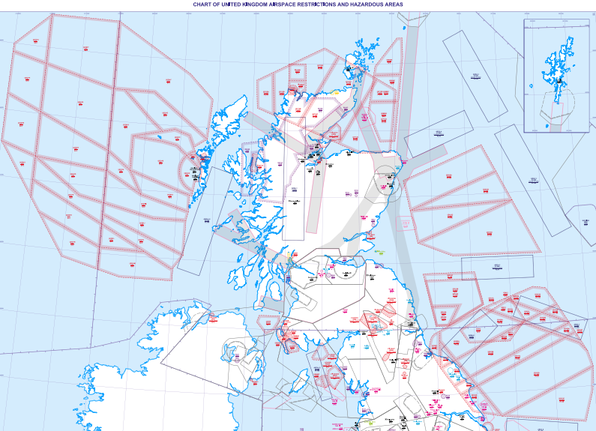

- Why is segregation needed?

A It is important to segregate high energy activity from other airspace users due to the dynamic nature of exercises and air combat manoeuvres as well as allowing supersonic flight.

- Why are parts of the FJAs over land?

A A vital part of modern warfare is Air Land integration. This can only be practiced where segregated airspace is allowed to be over land. This not only benefits training for military aircrew, but also for land forces to practice Joint Tactical Air Control (JTAC) in a live environment.

- How often will the FJAs be activated?

A The FJAs will only be activated during Ex JW periods – 2 weeks in Spring and Autumn. There will be a total of approximately 5 bookings per exercise for around 3 hours at a time. This is ‘worst case’, and in order to satisfy Flexible Use of Airspace (FUA) and Airspace Management (ASM) policy, bookings are managed by the Military Airspace Management Cell (MAMC) and maybe cancelled should weather, aircraft serviceability etc. be a factor.

6. Will both FJAs be activated at the same time?

A No. Due to the nature of Ex JW, the scenario only allows for one FJA to be activated at a time. Since 2010, there has historically been a 3:2 split of FJA(S) to FJA(N) activations.

7. Will the FJAs be activated outside of Ex JW?

A No. The purpose of the FJAs is to solely facilitate Ex JW and the training requirement it brings to the MoD and foreign participants.

8. What are the vertical dimensions of the FJAs?

A Both FJA(N) and FJA(S) are from FL245 to FL550.

9. How does this proposal impact General Air Traffic?

A. This proposal aims to establish segregated airspace in the upper air (FL245 and above). Due to the size of the FJAs, NATS have predicted there is an impact to the CO2e emissions. Further details of the report are found in the Stage 3A Consultation Document annex A.

