**ACP-2020-092**

**INCLUSION OF FJA INTO UK AIP**

**STEP 3A**

**CONSULTATION DOCUMENT**

**V2.1**



**Responsible Authors of this Document**

The Sponsor for this Airspace Change Proposal is the Ministry of Defence (MoD). The project team is drawn from the Joint Training Exercise Plans Staff (JTEPS).

|  |  |  |
| --- | --- | --- |
| **Position** | **Name** | **Role** |
| Project Lead | Sqn Ldr S D Blakemore | JTEPS SO2 ALI |
| Project Authority | Wg Cdr D Fowler | JTEPS SO1 Air |

Only responsible authors may implement amendments via the Project lead. All revisions will be listed and detailed in the table below.

|  |  |  |  |
| --- | --- | --- | --- |
| **Revision**  **Number** | **Affected part** | **Revised By** | **Notes** |
| V1.0 |  | Project Lead | Initial Issue. |
| V2.0 | 1.6.1 NATMAC stakeholder list match Stage 1 & 2 for consistency.  Additional Stakeholders added due to proximity of neighbouring airspace and local Spaceport Stakeholders with ACP submissions.  2.4 Consultation date altered due to CAA review.  4.1 Consultation duration mitigations added, and dates altered due to CAA review.  4.2 Details on how to request a virtual meeting added for clarity.  4.7 Details on how to submit a hard copy of the survey, and FAQ representation added for clarity.  4.8 Consultation dates altered.  4.9 Consultation dates altered. | Project Lead | Amendments after CAA Gateway Review. |
|  | Annex A  - Consolation dates altered & Return address added to Survey.  - Additional questions (11-13) on ASM procedures, LoAs and operating protocols added for further associated feedback.  All – Removal of the military parlance ‘kinetic’ & non kinetic’. |  |  |
| V2.1 | 4.6 Details on how to request a hard copy of any documentation added, as well as email address.  4.7 Email address added for offline FAQ representation.  All – Date of Consultation changed to 7th December 2022. | Project Lead | Amendments after CAA Gateway Review. |

**Contents**

**Glossary of Terms** iv

**Introduction** v

**Section 1 – Context**  1

Fast Jet Area (FJA) Overview 1

Local Airspace 1

Airspace Stakeholders 3

Why include the FJAs into the UK AIP? 5

**Section 2 – Proposed Options** 8

Design Principles 8

Conclusion 9

Operating Principles 9

**Section 3 – Effect of Proposed Options**  11

Air Traffic Sampling 11

Effect on aviation 11

Environmental Impact 13

Reversal statement 17

**Section 4 – Consultation Process** 18

Consultation Duration 18

Purpose 18

How to respond 19

Next Steps 19

**Annexes**

A Consultation Feedback Form

**Glossary of terms**

|  |  |
| --- | --- |
| ASACS | Air Surveillance And Control System |
| ACP | Airspace Control Proposal |
| AIP | Aeronautical Information Publication |
| AIRAC | Aeronautical Information Regulation and Control |
| CAA | Civilian Aviation Authority |
| CAP | Civilian Aviation Publication |
| DAATM | Defence Airspace and Air Traffic Management |
| FBZ | Flight Buffer Zone |
| FGEN | Force Generation |
| FIR | Flight Information Region |
| FJA | Fast Jet Area |
| FL | Flight Level |
| FRA | Free Route Airspace |
| FUA | Flexible Use of Airspace |
| GAT | General Air Traffic |
| JTEPS | Joint Training Exercise Plans Staff |
| JW | Joint Warrior |
| LoA | Letter of Agreement |
| NATO | North Atlantic Treaty Organisation |
| NATS | National Air Traffic Services |
| NM | Nautical Mile |
| NOTAM | Notice To Airmen |
| MAA | Military Aviation Authority |
| MAMC | Military Airspace Management Cell |
| MDA | Managed Danger Area |
| MoD | Ministry of Defence |
| SoN | Statement of Need |
| STRATFOR | Strategic Forecast |
| SUA | Special Use Airspace |
| TFR | Traffic Filter Region |
| UIR | Upper Information Region |
| UTC | Universal Time Coordinated |

**Introduction**

0.1 This document forms part of Stage 3 of the Airspace Change Proposal ACP-2020-092 and has been prepared in accordance with Civil Aviation Publication (CAP) 1616.

0.2 The aim of this document is to provide Stakeholders with the information that they require in order to fully understand the MoD’s proposal to include the Fast Jet Areas (FJA) into the UK AIP. This document will allow all Stakeholders to provide feedback on the airspace options as part of consultation.

0.3 The scope of this consultation is limited to the implementation of the inclusion of FJA North and South for use during Exercise Joint Warrior (JW).

0.4 This document provides context to the proposal, including background to the airspace usage and why the MoD is seeking to re-introduce it into UK Airspace.

0.5 Statement of Need (SoN). The Statement of Need was submitted to the CAA at Stage 1. It read as follows:

*In order to meet the complex training objectives of Defence during Ex JWs, a large scale multi-national military exercise, segregated airspace is required that:*

* *Is within reach of Navy Forces, more specifically a Carrier Strike Group (with embarked 5th generation air systems) operating within Deep Water, which through the development of the scenario is likely to span hundreds of miles.*
* *Provides a sufficient mixture of overland and overseas areas which offers exercise planners flexibility to create more complex scenarios across both environments, for necessary littoral operations.*
* *Crucially caters for ranges within the area, which allows for necessary Air Land integration.*
* *Is of large enough size to accommodate representative operational numbers. In order for UK Danger Areas to comply with both the UK’s Airspace Modernisation Strategy and incoming Free Route Airspace (FRA), every danger area requires a “parent” danger area in the UK AIP in order for Flight Buffer Zones to be applied and thus enable FRA. In an increasingly busy UK airspace, segregated airspace of a large enough size and in a suitable location will not exist after FRA is implemented and current solutions are untenable to deliver the required needs of Defence.*

0.6 Several iterations of stakeholder engagement have already been conducted up to this point. In conjunction with the Option Appraisals the MoD has developed an airspace option, centred around the Managed Danger Area airspace construct that it is seeking to consult stakeholders on.

**Section 1 – Context**

**Fast Jet Area (FJA) Overview**

1.1 The MoD identified a requirement for a suitable and safe airspace in the UK to facilitate Exercise JW, the largest tri-service military exercise in Europe, allowing for modern military air systems to train to their full capabilities in a joint operating environment. The MoD and NATS agreed the use of FJA(N) and FJA(S) through the Mil AIP. Introduction of Free Route Airspace in December 2021 prevented this, and no other current airspace will provide the MoD viable airspace to facilitate this essential Defence and wider NATO training.

1.2 Areas to be affected are at fig 1.

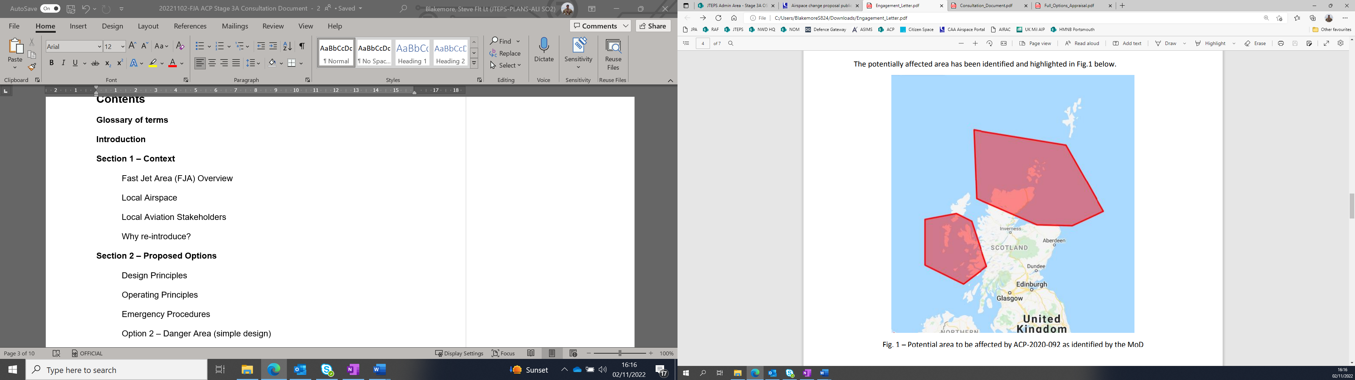

Fig 1 – Areas to affected by FJA North & South as identified by the MoD.

**Local Airspace**

1.3 Figs 2 and 3 shows the lateral dimensions of FJA North and South in relation to its surrounding MDAs and airspace taken from the Mil AIP ENR[1]. Fig 4 shows the lateral limits to the FJAs.

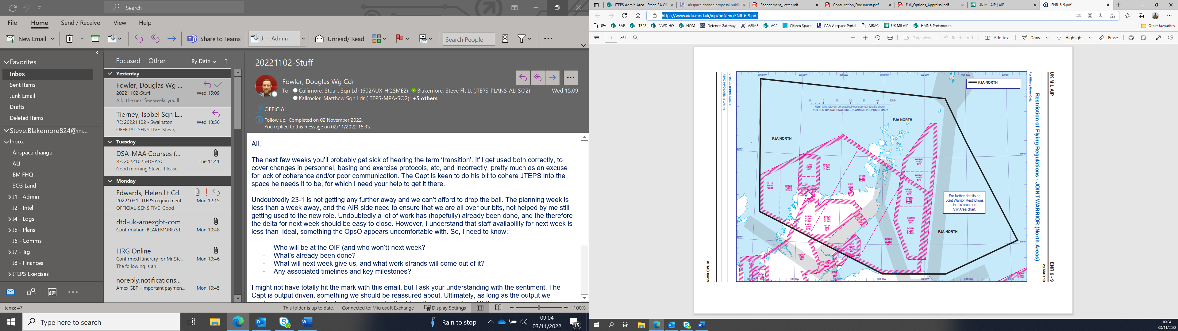

Fig 2 – FJA North.

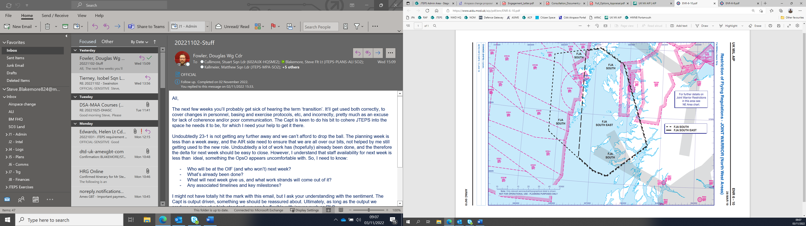

Fig 3 – FJA South

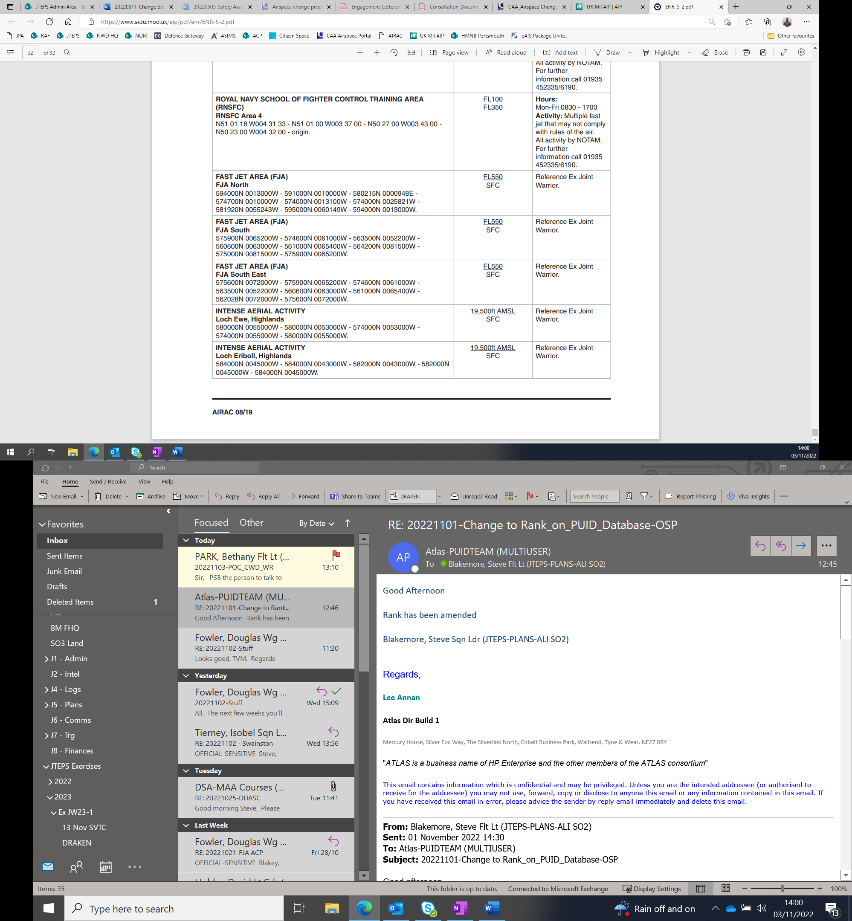

Fig 4 – Mil AIP ENR 5.2 dated 17 Jun 21

**Airspace Stakeholders**

1.4 This is a level M2 consultation - a proposed change where the anticipated consequences are either (a) an alteration of civil aviation traffic patterns at 7,000 feet or above[2] or (b) no impact on civil traffic - The MoD requirement for the FJA is a base level of FL245, a significant factor in reducing the impact on other airspace users and therefore reduces the amount of local airspace stakeholders.

1.5 Both FJA areas overlap already existing MDAs throughout UK airspace – these will all have operating authority through the MoD and will be managed by the Military Airspace Management Cell (MAMC) at 78 Sqn (formally Swanwick Military).

1.6 Airspace Stakeholders have been broken down into the following groups.

1.6.1 External Aviation Stakeholders

|  |  |  |
| --- | --- | --- |
| **NATMAC** | | |
| Airlines UK | Airspace4All | Airport Operators   Association |
| Airfield Operators Group | Aircraft Owners and Pilots Association | Airspace Change   Organising Group |
| Association of Remotely Piloted Aircraft Systems UK | Aviation Environment Federation | British Airways |
| BAe Systems | British Airline Pilots Association | British Balloon and Airship Club |
| British Business and   General Aviation   Association | British Gliding Association | British Helicopter   Association |
| British Hang Gliding and Paragliding Association | British Microlight Aircraft Association | General Aviation Safety Council |
| British Model Flying Association | British Skydiving | Drone Major |
| General Aviation Alliance | Guild of Air Traffic Control Officers | Honourable Company of Air Pilots |
| Helicopter Club of Great Britain | Heavy Airlines | Iprosurv |
| Isle of Man CAA | Light Aircraft Association | Low Fare Airlines |
| Military Aviation Authority | NATS | PPL/IR (Europe) |
| QinetiQ | United States Air Force Europe |  |

Due to the proximity of neighbouring airspace to the FJAs, the Scottish Upper Area (North) in fig 5, the addition of the following airspace users will be added as stakeholders:

|  |  |  |
| --- | --- | --- |
| Deeside Gliding Club (Aboyne) | The Scottish Gliding Centre (Portmoak) | The Highland Gliding Club (Easterton) |
| Cairngorm Gliding Club (Feshiebridge) |  |  |

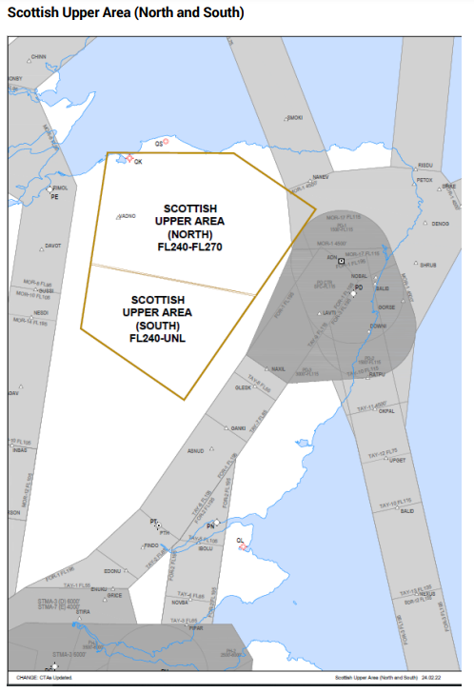

Fig 5 – Scottish Upper Areas

Additionally, since Stage 2, Spaceport Stakeholders have been identified from the following ACP submissions and have been added:

[ACP-2017-79](https://airspacechange.caa.co.uk/PublicProposalArea?pID=92) – Shetland Space Centre Satellite Vertical Launch Safety Area

[ACP-2019-04](https://airspacechange.caa.co.uk/PublicProposalArea?pID=125) – Space Hub Sutherland

[ACP-2021-012](https://airspacechange.caa.co.uk/PublicProposalArea?pID=344) – Spaceport 1 Scolpaig North Uist

[ACP-2021-058](https://airspacechange.caa.co.uk/PublicProposalArea?pID=402) – HyImpulse Sounding Rocket Launch from Saxa Vord Spaceport - Shetland

|  |  |  |
| --- | --- | --- |
| Highlands and islands Enterprise | Hylmpulse | Shetland Space Centre |
| QinetiQ |  |  |

1.6.2 Internal MOD Stakeholders.

|  |  |  |
| --- | --- | --- |
| **Internal MoD Stakeholders (*via DAATM)** | | |
| HQ 1 Group* | HQ 2 Group* | 11 Gp A7* |
| 19 Sqn* | 78 Sqn* | 2 Group DAAM* |
| Military Aviation Authority  (MAA) | Defence Airspace and Air Traffic Management (DAATM) | Navy Command HQ |

**Why include the FJAs into the UK AIP?**

1.7 Extant airspace structures at the end of 2021 would not fulfil the requirements for Ex JW. D323s, 513s and 613s are too far away from Maritime Forces operating in deep water in the Atlantic Ocean and too small for needs of Ex JW. Airspace structures in the North-West of the UK; namely D701 complex and D712 complex fall short of our requirement as well. The D712 complex is too small to accommodate representative operational numbers. D701 complex is used for a broad range of activities including trials and has significant limitations placed against it for its annual use, due to the impact on Oceanic routing for general air traffic. Therefore, it cannot be relied upon to regularly meet our bi-annual needs. Notwithstanding, it doesn’t have suitable areas of land beneath it for effective joint operations training. Fig 6 shows a Chart of UK Airspace restrictions and Hazardous areas.

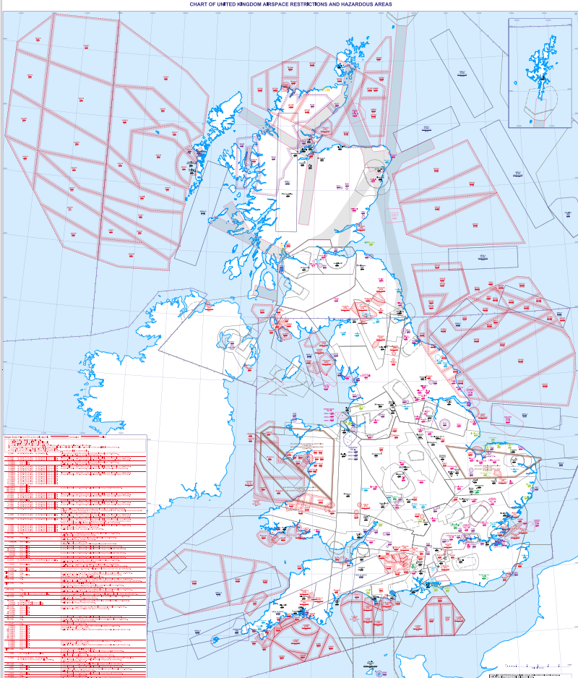

Fig 6 – Chart of UK Airspace restrictions and Hazardous areas.

1.8 The key principles and requirements for the airspace are:

* The airspace design must be safe, with any hazards identified and risks mitigated such that they are as low as reasonably practicable (ALARP) and tolerable.
* The design will provide a suitable training area to meet the following core requirements:
* Is within reach of Navy Forces, more specifically a Carrier Strike Group (with embarked 5th generation air systems) operating within Deep Water, which through the development of the scenario is likely to span hundreds of miles.
* Provides a sufficient mixture of overland and overseas areas which offers exercise planners flexibility to create more complex scenarios across both environments, for necessary littoral and amphibious operations.
* Crucially caters for ranges within the area, which allows for necessary Air Land integration.
* Is of large enough size to accommodate representative operational numbers.
* Safe, efficient and standardised management as well as notification and activation of airspace, utilising Flexible Use of Airspace (FUA) principles.
* Will be FL 245 and above, and suitable dimensions to minimise impact on other airspace users and the network, where possible.
* Minimise noise and environmental impacts, where relevant.

**Section 2 – Proposed Options**

**Design Principles**

2.1 At Stage 1 the Sponsor, with feedback from Stakeholders, established a set of Design Principles in which to guide the airspace design options. The design principles agreed at the Stage 1 and 2B Gateway are as follows:

|  |  |
| --- | --- |
| **Priority** | **Design Principles** |
| 1 | DP(a) The airspace design must be safe, with any hazards identified and risks mitigated such that they are as low as reasonably practicable and tolerable. |
| 2 | DP(b) Must be within reach of Navy Forces, more specifically a Carrier Strike Group (with embarked 5th generation air systems) operating within Deep Water, which through the development of the scenario is likely to span hundreds of miles.  DP(c) Provides a sufficient mixture of overland and overseas areas which offers exercise planners flexibility to create more complex scenarios across both environments, for necessary littoral operations.  DP(e) Must be of large enough size to accommodate representative operational numbers.  DP(g) Will be FL 245 and above and suitable dimensions to minimise impact on other airspace users and the network, where possible. |
| 3 | DP(d) Crucially caters for ranges within the area, which allows for necessary Air Land integration.  DP(i) Minimise environmental impacts, where relevant. |
| 4 | DP(f) Safe, efficient and standardised management, notification and activation of airspace, utilising Flexible Use of Airspace (FUA) principles.  DP(h) Minimise noise impacts, where relevant. |
| 5 | DP(k) Protocols for the prioritisation of area activation shall be established to minimise the accumulative overall effect of Defence airspace needs on other airspace users.  DP(j) The design shall provide a Flight Plan Buffer Zone (FBZ) for the purposes of Free Route Operations and flight planning. |

2.2 Option 0, the do-nothing option, aimed to examine whether alternatives existed which would still facilitate the air elements of Ex JW in accordance with the SoN. There are elements of the current MDAs that do satisfy individual DPs, however there is no specific danger area or combination of danger areas that can be used to facilitate the MoD’s requirements. Lastly, evaluating this option against 11 DPs, it only partially meets 6 and does not meet 1 - (g) There are MDAs which are FL245 and above, however, impact on other airspace users will not be able to be minimised as existing airspace structures will have to be used. This means Ex JW activity would conflict with other military and non-military activity that is occurring in the danger areas, particularly EG D701s with the increase in commercial ventures such as space launches. Showing clearly the current structures are unfit for Ex JW.

2.3 Option 1 meets 9 out of the 11 DPs, with 2 DPs partially met (DP(g) – due to impact on GAT, and (i) – due to the environmental impact on GAT re-routing). With any large force exercise there will always be an impact to other airspace users. Producing a Letter of Agreement to suppress other airspace during FJA activation and having the airspace AMC managed will mitigate this impact. This is largely the same for environmental impacts; where the MoD’s requirement is to operate in large, segregated airspace, GAT will be routed around. The design also satisfies SoN (para 0.5), allowing the MoD to have a geographically relevant segregated airspace in which to exercise modern joint and foreign elements for Ex JW.

**Conclusion**

2.4 The proposed option, ‘Establishing FJA(N) and FJA(S) as per previous dimensions’, option 1, satisfies both the SoN at para 0.5, Key Principles at para 1.8, and meets 9 out of the 11DPs. It is significantly greater than option 0, do nothing (baseline and comparator), **therefore option 0 is discounted as a design option.** **Option 1 is the only design option that the change sponsor is seeking feedback on**. The DPs that are identified as ‘partial’ will be met with further consultation with stakeholders through the Consultation Feedback Form, available at both annex A and the [Citizen Space Portal](https://consultations.airspacechange.co.uk/mod/inclusion-of-fja-into-uk-aip) when the consultation period begins on Wednesday 7th December 2022. Continued engagement and consultation will take place with all findings taken into consideration.

**Operating Principles**

2.5 **Activation.** The FJAs will be activated by the MAMC via NOTAM when required only during Ex JW (2 week period during Spring and Autumn) in accordance with previous practice. When activated, the FJAs will be afforded the segregated status of Special Use Airspace (SUA) between FL245 and FL550, as defined in CAP 740 Appendix A.

2.6 **Frequency of flights.** It is anticipated that during each of the Exercise JW execute phase, there will be approximately 5 activations of the FJAs (total 10 with a 3:2 split of South and North usage[3]).

2.7 **Hours of Operation.** During exercise periods, FJAs will be active for up to 3 hours from mid-morning (c1030 UTC). However, under the EUROCONTROL Flexible Use of Airspace (FUA), the airspace will be managed and handed to Civil use should the FJA not be required (cancellation of aircraft, poor weather, sortie completed early etc.)

2.8 **GAT.** NATS PC will manage the safe and efficient flow of GAT around the FJAs by use of Free Route Airspace (FRA) to facilitate circumnavigation.

2.9 **Operating Authority/OAT.** ASACS units are the Operating Authority for air systems operating within the MDAs/FJA. 78 Sqn is tasked with providing a service to air systems routeing in and out of the MDAs and, in addition, when ASACS is unavailable, for providing a service to air systems operating within them[4].

2.10 **Letters of Agreement.** After Stakeholder engagement post step 2B (Develop and Assess Gateway), the Change Sponsor agrees to create a Letter of Agreement (LoA) in order to ensure that the impact on the civil route network is minimal, previously used SUA activation protocols will be established:

*C.1.8 In accordance with MoD policy, the MAMC is responsible for ensuring that EG D701E and/or EG D701F activation at or above 29,000ft is not concurrent with EG D712 activation or Military Exercises operating in adjacent Fast Jet Area South (FJAS) or Fast Jet Area North (FJAN). These areas cannot be active at the same time period to allow GAT to transit safely to the east of EG D701E and/or EG D701F.*

This is based on a previous LoA currently within Mil AIP ENR 5-1-7 (fig 7).

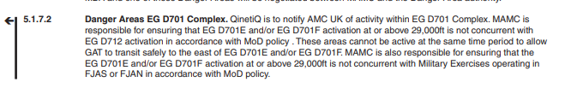

Fig 7 – Mil AIP ENR 5–1–7 dated 12 Aug 21.

2.11 Intense aerial activity can be expected with large formations of fast jet attack aircraft (an excess of 40) conducting high energy evasive manoeuvres against opposing air defence aircraft. Aircraft operating within in the FJA may require to conduct manoeuvres lower than the FJA base level of FL245. In these instances, pilots will operate lower in accordance with the airspace classification.

**Section 3 – Effect of Proposed Options**

3.1 As a result of step 2A and the Design Principle Evaluation, only one option alongside the ‘do nothing’ baseline was carried forward; The inclusion of FJA(N) and FJA(S) into UK airspace. Section 3 of this document shows the effect of this proposed option.

**Air Traffic Sampling**

3.2 An Environment Impact Assessment (A22152) was conducted and was based on the following ‘worst case’ assumptions:

* 2x Exercises a year that require the FJAs.
* 5x activations of the FJAs per exercise (10 total).
* FJA(N) and FJA(S) will not be activated at the same time.
* Most common activation is between 1030-1330 UTC.
* Sole activation of FJAs i.e., does not include activation of nearby/overlapping MDAs.

3.3 Simulated baseline air traffic models have been produced using tool NEST (V1.8) and Emissions figures have been produced using BADA 4.2 data. There products have been made available by the European Organisation for the Safety of Air Navigation (EUROCONTROL).

3.4 The traffic sample was taken from the 2205 AIRAC from EUROCONTROL. This AIRAC was chosen to balance the most common activation month (May) with traffic levels returning after the Covid pandemic. A 2022 AIRAC was required to give an up-to-date baseline set of traffic that was not considerably impacted by the Covid-19 pandemic.

3.5 The following 5 days were picked to simulate; 24/05/2022, 30/05/2022, 09/06/2022, 13/06/2022 and 15/06/2022. These 5 days were picked to give a good overall representation of traffic, with the following factors considered; Oceanic Track location (northerly or southerly), Weekday and Traffic count.

3.6 Traffic included must have crossed the Traffic Filter Region (TFR) or the UK FIR shown at fig 8 during the sample days above. The TFR has been modified to include an area around the Scottish UIR to capture traffic that did not route through the UK FIR on the sample days but would be affected by the changes if the traffic did so. The traffic sample is defined as any flight whose simulated trajectory changed due to the activation of FJA(N) and FJA(S).

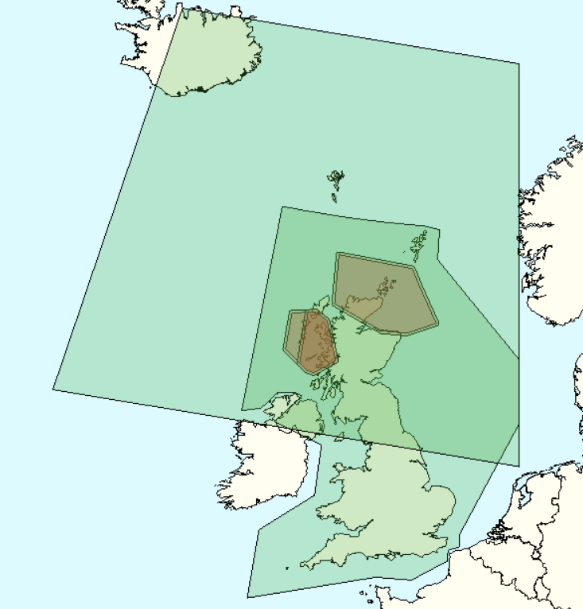

**UK FIR**

**Traffic Filter Region**

**FJA(N)**

**FJA(S)**

Fig 8 – Traffic Filter Region

**Effect on aviation**

3.7 Due to the proximity of the danger areas to the western and northern edges of the UK FIR (London and Scottish UIRs), many flights need to change their UK entry/exit point between the baseline and scenario simulations to produce a valid flight plan. Therefore, the trajectories were simulated within a larger area of airspace called the Simulated Region.

3.8 The Simulated Region is shown at fig 9. It encompasses a section of the oceanic airspace to allow for a degree of change to the Oceanic Entry/Exit point (OEP) to the UK and encompassed a portion of European airspace. This allows transatlantic flights enough area to transverse around the active danger areas while ensuring that the North Atlantic Tracks remained largely unchanged.

3.9 Example trajectories are shown in fig 10. The scenario models show an example of an aircraft trajectory with either FJA activated. The black dots mark the points the aircraft enters and exits the UK FIR.



Fig 9 – Simulated Region

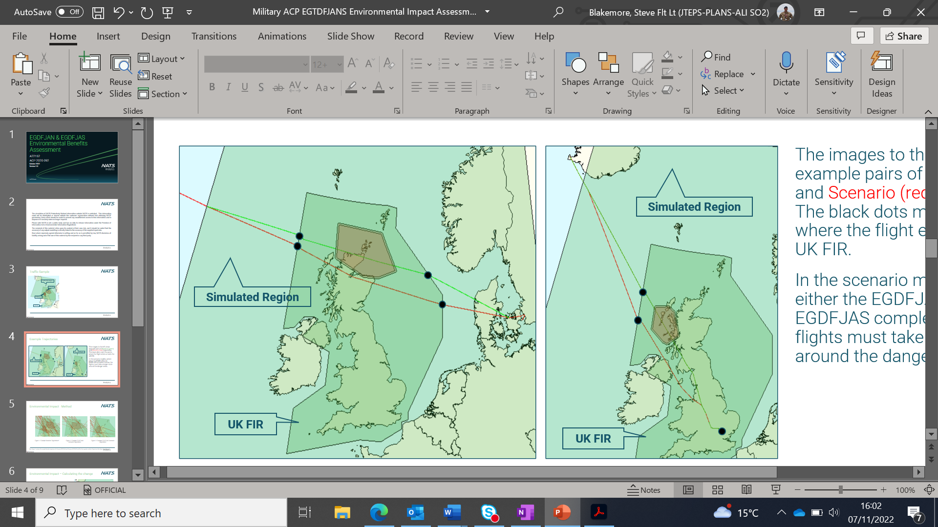

Fig 10 – Example trajectories

**Environmental Impact**

3.10 **Method.** The track distance flown of affected flights was taken from the Baseline and Scenario models and used to calculate the change in distance flown. The fuel burn at cruise by aircraft type was then taken from the BADA 4.2 data tables and used to calculate the fuel burn change based on the change in distance flown.

3.11 The traffic was used to represent an activation of FJA(N) or FJA(S) and the number of activations have been scaled to represent an annual benefit (2 exercises (10 total activations) per year assumed based on the historical activation and agreed with the MOD). Fig 11 shows an example of the baseline trajectories vs activation of either FJA.

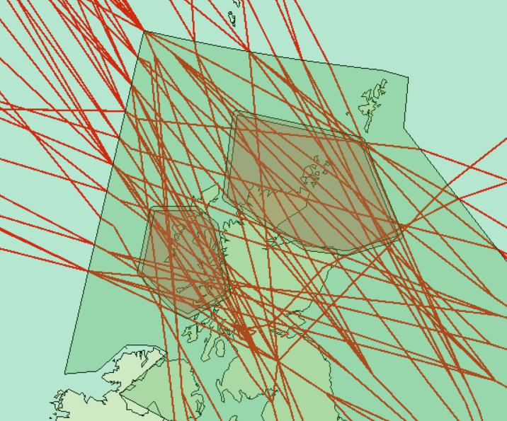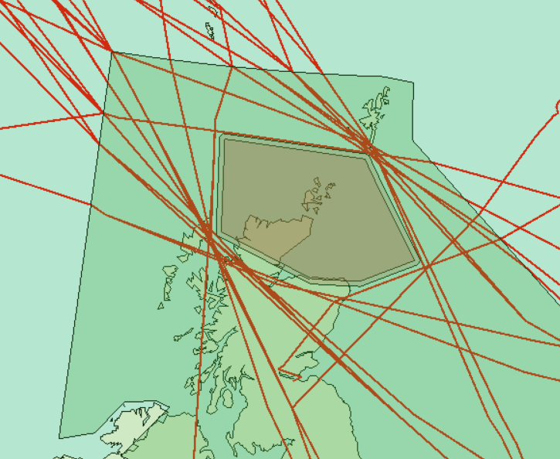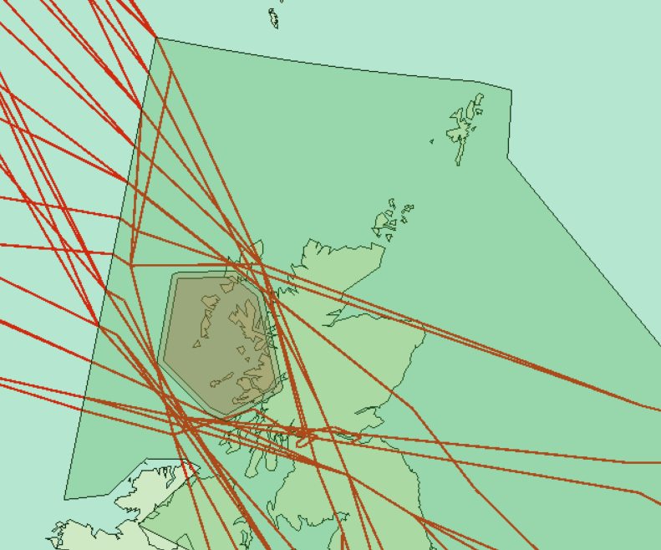

Fig 11 – Example of Baseline trajectories vs FJA(N) or FJA(S) activation.

3.12 Traffic was grown using the October 2021 STATFOR forecast and the NATS forecast when STATFOR was not available, to estimate the annual impact to 2033 (10 years post deployment).

3.13 **Calculating the change.** The change in track distance is modelled both as a change in distance within the UK FIR and across the whole trajectory. When viewed as a change only with the UK FIR, the scenarios produced some flights with a reduction in track distance and therefore environmental benefit, example in fig 10. Modelling just for the UK FIR in this example would give a track distance saving of c320NM against an overall trajectory increase of 7NM (scenario – baseline), because of the changes in UK entry and exit fixes. As the implementation of the proposed ACP is to implement areas of airspace that cannot be crossed, it is not sensible for flights to show an improvement in track distance. Therefore, the findings will only report on the ACPs impact to the whole trajectory to be truly representative of the environmental impact.

3.14 **Assumptions.** Along with the assumptions made in para 3.2, the modelling took the following into account:

* The fuel impact of this change would manifest as track distance changes while flights are at cruise (the average fuel burn change is calculated from all affected flights across the sample days.)
* Average of 246 flights per activation period.

- Per Activation -145 flights affected for FJA(N) / 313 flights affected for FJA(S).

- 10:30 to 13:30 UTC is the most common activation time planned in 2023 and is therefore assumed to be the average activation period.

* The fuel burn results have been calculated from the average fuel burn per flight from all flights affected on the samples days, multiplied by the average number of flights during the proposed activation times to give a benefit for an average single activation. This value has been multiplied by the estimated number of activations to get the annual values.
* 1% of emissions are traded, 99% are non-traded - For WebTAG submission, the CO2e emissions are reported as traded (flights whose origin and destination are within the EU) or non-traded.
* All tracks that benefit from a re-route were discounted, fig 12 shows an example.

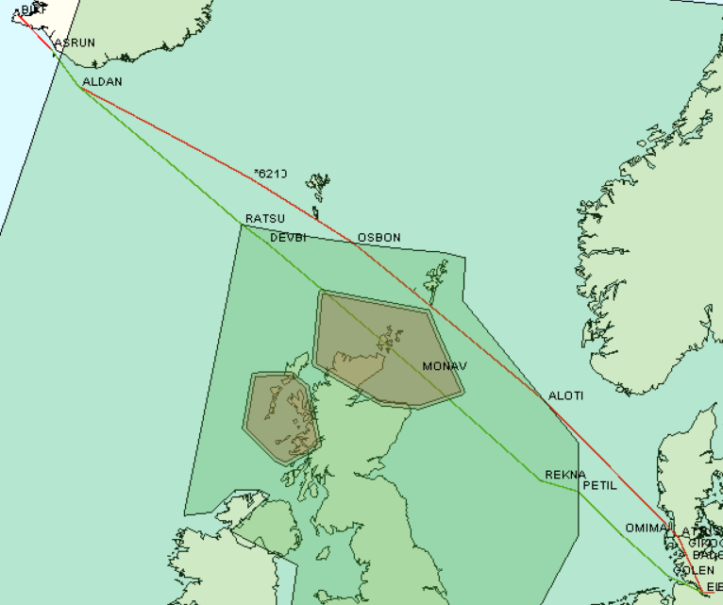

Fig 12 – Example of Environment benefit.

3.15 **Results.** The average route length, fuel burn and carbon dioxide equivalent (CO2e) emissions per flight are given in the table below. The average flight has an increased track distance, subsequently increasing the fuel burn and related

emissions.

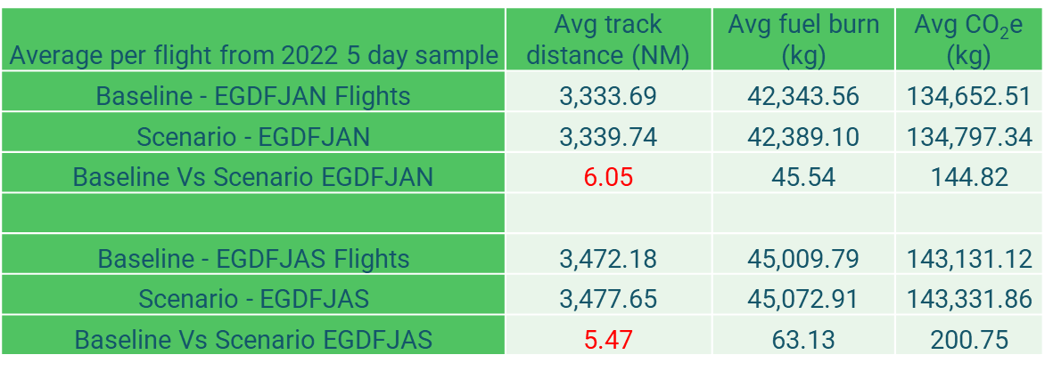

*(Note: CO2e is a standard measurement that considers the impact of all greenhouse gas emissions due to fuel burn as if they were all carbon dioxide. For aviation fuel, the conversion rate is 1kg fuel to 3.18kg of CO2e.)*

3.16 The table below shows the annualised impact of this change in terms of fuel burn and CO2e emissions for years 2023 – 2033.

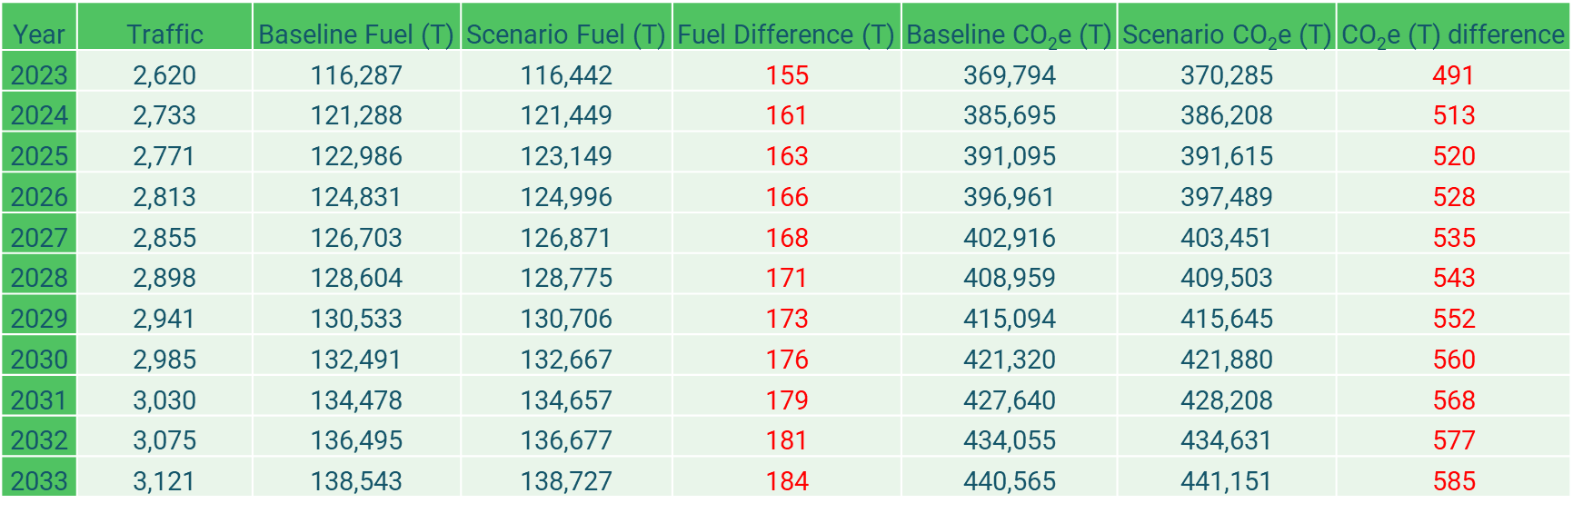

*Note: Positive numbers indicate additional contributions (penalty), negative numbers indicate lower contributions (benefit).* *Calculations are performed on unrounded numbers. Results are displayed to 0 decimal place*

3.17 The table below shows the annualised impact of this change in terms of fuel burn and CO2e emissions for years 2023 –2033 broken down by danger area.

**EGDFJAN**

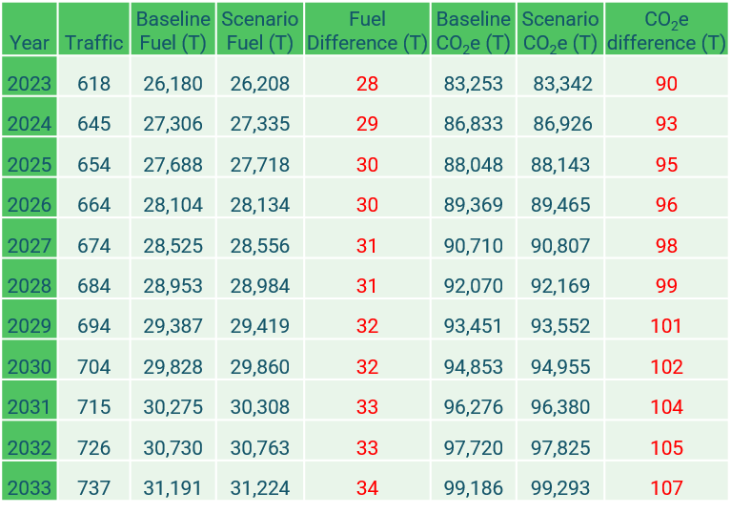

**EGDFJAS**

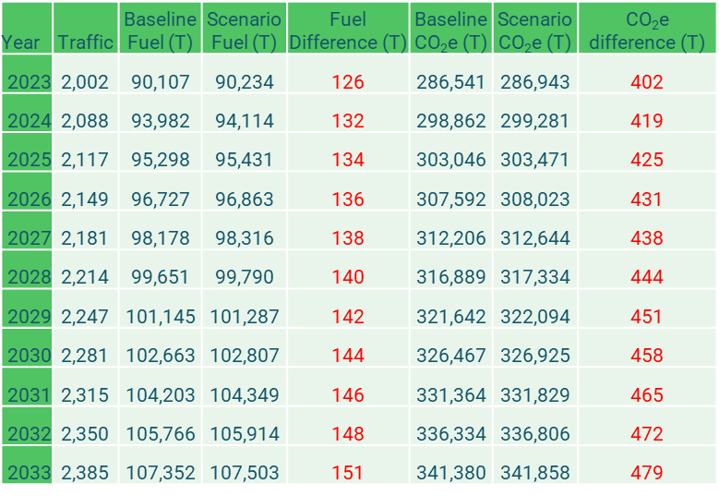

**Reversal statement**

3.18 As per CAP 1616[5], the Sponsor must provide a reversal statement to articulate the actions if the airspace change does not achieve its objectives post-implementation.

3.19 As the Sponsor is seeking Special Use Airspace that will be activated by NOTAM, should the airspace not achieve its intended aims, the MoD will not activate it. Thereby not causing any impact to air users. Subsequent actions will see the MoD seeking an airspace re-design (requiring the Sponsor to conduct another airspace change) or request a full removal from the AIP.

**Section 4 – Consultation Process**

**Consultation Duration**

4.1 Subject to CAA feedback, the Sponsor will look to conduct a 12-week consultation as a result of a number of factors with potential impact over the Christmas and New Year period:

* Previous engagement has identified that some stakeholders hold meetings on a monthly basis thereby limiting the opportunities for organisations to formally discuss the proposal as a collective.
* Owing to the upcoming Christmas holidays, a 12-week consultation will ensure all stakeholders have had sufficient time to receive documentation, attend a consultation event (if desired) and respond.
* The FJAs were extant up until Dec 2021. The majority of impacted stakeholders for the airspace, FL245 and above, will have already operated with them active within UK airspace.
* Stakeholders have been engaged from the beginning of the proposal (August 2021), with positive feedback being received.
* Survey responses will be reviewed post Christmas and New Year period (~6 working days). Reminders to stakeholders will be sent on Tuesday 3rd January 2023 and another Thursday 2nd February (3 weeks prior to consultation ending).

4.2 As per the Consultation Strategy, should stakeholders wish to have a virtual consultation, a meeting can be arranged by emailing or writing to the change sponsor as per the details at para 4.7.

**Purpose**

4.3 The purpose of this consultation period is to provide an opportunity for all stakeholders to comment on the proposed airspace design option. This feedback will be collated and analysed by the Sponsor and help to shape the final proposal that will be submitted to the CAA.

4.4 The key themes that the Sponsor is seeking to answer through consultation include, but is not limited to, the following:

* The perceived effect of this proposal (positive or negative).
* Key concerns for stakeholders.
* Mitigating factors that could be employed to minimise impact.

**How to respond**

4.5 In accordance with CAP1616 this consultation will be undertaken through electronic communication and it is therefore requested that stakeholders wishing to provide feedback do so through the Online Survey on the Citizen Space portal.

4.6 A link to the Citizen Space Portal can be found [here](https://consultations.airspacechange.co.uk/mod/inclusion-of-fja-into-uk-aip). All consultation documentation can be found at the link, additionally all relevant documentation so far can be found at the CAA airspace change portal, found [here](https://airspacechange.caa.co.uk/PublicProposalArea?pID=319). Should stakeholders want to request a hard copy of any documentation, they can write to the postal address in para 4.7, or email: [air-fastjetareasproposal@mod.gov.uk](mailto:air-fastjetareasproposal@mod.gov.uk)

4.7 Should stakeholders wish, they can submit a written survey response (annex A). On receipt, it will be uploaded the CAA portal. Postal address:

FAO: Sqn Ldr Steve Blakemore

JTEPS

The Old Iron Foundry

6 Queen Street

HMNB Portsmouth

PO1 3HL

Should stakeholders wish to make or receive FAQ representation offline, they can do so by writing to the change sponsor direct at the address above or to [air-fastjetareasproposal@mod.gov.uk](mailto:air-fastjetareasproposal@mod.gov.uk).

**Next Steps**

4.8 Consultation responses will be collated and assessed throughout the consultation period. Once the consultation period has closed on Friday 24th February 2023, the Sponsor will analyse and categorise all responses received and a consultation report published articulating the categorisation process, articulate issues raised and how they have been resolved. Finally, it will confirm the option to be submitted to the CAA or what additional amendments are to be made to the chosen design as a result of consultation feedback. The Sponsor will then upload the document to the Portal once the CAA has confirmed that no further consultation is required.

4.9 Timeline of steps and gateways:

|  |  |  |
| --- | --- | --- |
| Stage/Step | Description | Gateway Date |
| 3B | CONSULT Gateway | 5th December 2022 |
| 3C | Consultation Launch | 7th December 2022 |
|  | Reminder to Stakeholders | 3rd January 2023 |
|  | Reminder to Stakeholders | 2nd February 2023 |
| 3D | Collate and review responses from consultation. | 24th February 2023 |
| 4A | Update design | 3rd March 2023 |
| 4B | Submit Airspace Proposal to the CAA | 17th March 2023 |
| 5 | DECIDE Gateway | 2nd June 2023 |
| 6 | IMPLEMENT into AIRAC 09/2023 | 9th June 2023 |

4.10 The Sponsor will continue the ACP process in accordance with the timeline agreed, submitting all required documentation in Stage 4A and 4B in order to allow the CAA to conduct the DECIDE gateway for 2nd June 2023.

**Appendix A – Consultation Feedback Form**

*The following is the print copy of the online Consultation Feedback Form that will be distributed to stakeholders upon request*

**Inclusion of the FJA into UK AIP, ACP-2020-092**

The MoD identified a requirement for a suitable and safe airspace in the UK to facilitate Exercise Joint Warrior (ex JW), the largest tri-service military exercise in Europe, allowing for modern military air systems to train to their full capabilities in a joint operating environment. After the introduction of Free Route Airspace in December 2021, the airspace structures that we use - Fast Jet Area (FJA) North and Fast Jet Area South - ceased to exist and no other current airspace will provide the MoD viable airspace to facilitate this essential Defence and wider NATO training.

The purpose of this consultation feedback is for all stakeholders to be able to respond effectively to the information provided. The feedback form will assist in gathering and considering opinions and information from relevant stakeholders regarding the potential impact of this ACP.

The methodology of this consultation is summarised in the Consultation Strategy, which can be read in conjunction with the Consultation Document and the Full Options Appraisal. The consultation period is from 7th December 2022 to 24th February 2023. Once consultation has ended, all feedback will be considered for the final design proposal. The final design proposal may evolve from that described in the Consultation Document, subject to stakeholder input.

1. What is your name?

|  |
| --- |
|  |

1. What is your email address?

|  |
| --- |
|  |

1. Please enter your postcode.

|  |
| --- |
|  |

1. Are you responding as an individual or do you represent an organisation?

|  |
| --- |
|  |

1. If you are responding on behalf of an organisation, what is the name of the organisation?

|  |
| --- |
|  |

1. If you are responding on behalf of an organisation what is your position/title?

|  |
| --- |
|  |

1. What best describes your association with this airspace change?

Aviation Stakeholder NATMAC Organisation Other

Please state in the box below

|  |
| --- |
|  |

1. Please circle your response to the Airspace Change Proposal 2020-092.

Strongly Support Support Neutral Object Strongly Object

1. Please explain your response to Q8.

|  |
| --- |
|  |

1. The MOD is keen to reduce the impact of its operation on other airspace users. What mitigations would you suggest that would resolve concerns that you have?

|  |
| --- |
|  |

1. What feedback, if any, do you have on the Airspace Management (ASM) procedures?

|  |
| --- |
|  |

1. What feedback, if any, do you have regarding extant, or intended, Letters of Agreement (LoA) for the FJAs?

|  |
| --- |
|  |

1. What feedback, if any, do you have for the operating principles of the FJAs?

|  |
| --- |
|  |

1. Are there any other general considerations that you would like the MOD to consider in relation to this Airspace Change Proposal?

|  |
| --- |
|  |

1. In accordance with CAP1616, consultation responses will be published on Citizen Space via the CAA Airspace Change Portal. Responses will be subject to moderation by the CAA. Please indicate below if you would prefer for your response to be published anonymously (personal details will only be seen by the CAA).

Publish Response

Publish Response Anonymously

Once complete, please post to:

FAO: Sqn Ldr Steve Blakemore

JTEPS

The Old Iron Foundry

6 Queen Street

HMNB Portsmouth

PO1 3HL

1. [Mil AIP ENR 6-9 & 6-10 Dated 28 Mar 19](https://www.aidu.mod.uk/aip/aipVolumes.html#enr-tab).
2. [CAP1616 Page 26](https://publicapps.caa.co.uk/docs/33/CAA_Airspace%20Change%20Doc_Mar2021.pdf)
3. Historical activation data 2018-2022, NATS Environmental Impact Assessment A22152.
4. RAF 2 Group HQ Battlespace Management Orders Ed2 V.1.1 Para 128.1, dated 15 September 2022.
5. [CAP1616 Para 155](https://publicapps.caa.co.uk/docs/33/CAA_Airspace%20Change%20Doc_Mar2021.pdf)