**ACP-2020-092**

**INCLUSION OF FJA INTO UK AIP**

**STEP 3A**

**OPTIONS APPRAISAL (PHASE II – FULL)**

**V2.1**



**Responsible Authors of this Document**

The Change Sponsor for this Airspace Change Proposal is the Ministry of Defence (MoD). The project team is drawn from the Joint Training Exercise Plans Staff (JTEPS).

|  |  |  |
| --- | --- | --- |
| **Position** | **Name** | **Role** |
| Project Lead | Sqn Ldr S D Blakemore | JTEPS SO2 ALI |
| Project Authority | Wg Cdr D Fowler | JTEPS SO1 Air |

Only responsible authors may implement amendments via the Project lead. All revisions will be listed and detailed in the table below.

|  |  |  |  |
| --- | --- | --- | --- |
| **Revision**  **Number** | **Affected part** | **Revised By** | **Notes** |
| V1.0 |  | Project Lead | Initial Issue. |
| V2.0 | 3.1 & 3.2 Addition clarity on proposed option 0 being discounted and option 1 as the only option seeking stakeholder feedback.  3.6 Consultation dates altered due to CAA review.  Annex A – All – Altered carbon impact to a ‘cost’, for clarity.  All – Removal of the military parlance ‘kinetic & non kinetic’  . | Project Lead | Amendments after CAA Gateway Review. |
| V2.1 | All – Date of Consultation changed to 7th December 2022 | Project Lead | Amendments after CAA Gateway Review |

**Contents**

**Introduction**  iii

**Section 1 – Context** 1

Engagement 1

Environment and Noise assessment 1

Safety Assessment 1

**Section 2 – Full Option Appraisal** 4

Design Principles 4

Option 0 – Do Nothing 6

Options Appraisal 6

Summary 8

Option 1 – Including FJA(N) and FJA(S) into UK AIP 10

Operating Principles 11

Options Appraisal 12

**Section 3 – Conclusion** 15

Summary 15

ACP Timeline 16

**Annexes**

**A Environmental Impact Assessment**

**B Greenhouse Gases WebTAG**

**Enclosures**

**1. WebTAG Greenhouse Gases FJA Workbook.xlsx**

**Introduction**

**Scope**

0.1 This document forms part of Stage 3 of the Airspace Change Proposal, ACP-2020-092, which is for the inclusion of the FJAs into the UK AIP. The MoD identified a requirement for a suitable and safe airspace in the UK to facilitate Exercise Joint Warrior (ex JW), the largest tri-service military exercise in Europe, allowing for modern military air systems to train to their full capabilities in a joint operating environment. The MoD and NATS agreed the use of FJA(N) and FJA(S) through the Mil AIP. Introduction of Free Route Airspace in December 2021 prevented this, and no other current airspace will provide the MoD viable airspace to facilitate this essential Defence and wider NATO training.

0.2 The aim of this document is to provide evidence to the CAA that the Change Sponsor has adhered to the process laid out in CAP1616 for Stage 3 prior to the Consult Gateway. It aims to build upon the work undertaken during the Initial Options Appraisal in Stage 2 and develop the remaining airspace options in greater detail.

0.3 The deadline for the project is to include FJA(N) and FJA(S) into the UK AIP, targeting AIRAC 09/2023 in order for their use in Ex JW 23-2 (planned October 2023).

**Summary of Stage 2 Initial Options Appraisal**

0.4 The Initial Options Appraisal appraised (against the ‘do nothing’ baseline) the inclusion of previously utilised segregated airspace of both FJA(N) and FJA(S). As a result of stage 2A and the Design Principle Evaluation, only one option alongside the ‘do nothing’ baseline was carried forward – To include the FJAs into the UK AIP.

**Section 1 – Context**

**Engagement**

1.1 Since stage 2, there has been no further information requested from the Stakeholders, and none required from the Change Sponsor.

**Environmental Assessment**

1.2 The ACP Change sponsor is the MoD and is therefore only responsible for assessing the consequential impact on civil air traffic. An Environmental Impact Assessment was conducted to concentrate on CO2e (required only as a level M2 submission) emissions from the civil air traffic disruption during the activation of either FJA. The Environmental Impact Assessment is based on a ‘worst case’ scenario for length/duration of FJA activation including an air traffic track simulation. The full assessment can be found at annex A.

**Safety Assessment**

1.3 A safety assessment was presented with the Stage 2 Options Appraisal (Phase I) Initial. It is repeated here with amendments to report searches and up to date information. The rest of the report has remained extant since it has not been necessary due to no alteration to the previous FJA(N) and FJA(S) design or locations.

1.4 This assessment provides a qualitative overview of the impact of this ACP on flight safety. The evidence feeding into this safety assessment has been obtained from the results of previous activations of the FJAs. The MoD have successfully employed several methods in the past to ensure the safety and integrity of the Fast Jet Areas during their use, such as its classification as segregated airspace, Flight Buffer Zones (FBZ) and positive control from an ASACS unit.

1.5 Currently, airlines plan their route incorporating FRA above FL245, allowing the freedom to plan and fly their optimal route considering things such as weather and wind speed. This freedom allows closer routing to active FJA and as such should have a reduced impact than the previous airway routes.

1.6 The Change Sponsor has conducted a Defence Air Safety Occurrence Report (DASOR) search through the Air Safety Information System (ASIMS), as well as a UK Airprox Board search for any safety incidents relating the use of FJAs during any of the previous activations since 1st January 2008. Search criteria within ASIMS were for ‘location’ to include ‘FJA’ or ‘Fast Jet Area’, fig 1 shows the search results. Of the 11 found, 10 were from an Ex JW, the 11th is an operational report containing ‘fja’ in the location and must be discounted. The most notable reports to effect GAT flight safety were:

* 4 Apr 19 - 3x Civil aircraft entered FJA(S) due to PC unawareness of airspace booking. Resolved by NATS incorporate a 2-step check on NOTAMS.
* 14 Oct 19 - Aircraft allowed to depart FJA without being under positive control due to a misunderstanding of the surrounding airspace by the controlling agency. Resolved with re-briefing the aircrews and foreign fighter controllers on airspace layout.
* 17 Oct 20 - Fast Jet changed to operating frequency for the FJAs whilst still outside in controlled airspace. This was due to confusion in an ATC instruction and a frequency code name. Resolved by no longer using that code name in the frequency allocation plan.

1.7 The resolutions listed above were all recommendations that are now implemented with their appropriate sponsors. All safety incidents related to the FJAs were not due to the design or location of the airspace, but operating practices which are now mitigated against and will be emphasised by the JTEPS (unit within the MoD that run and plan Ex JW) safety team prior to each exercise.

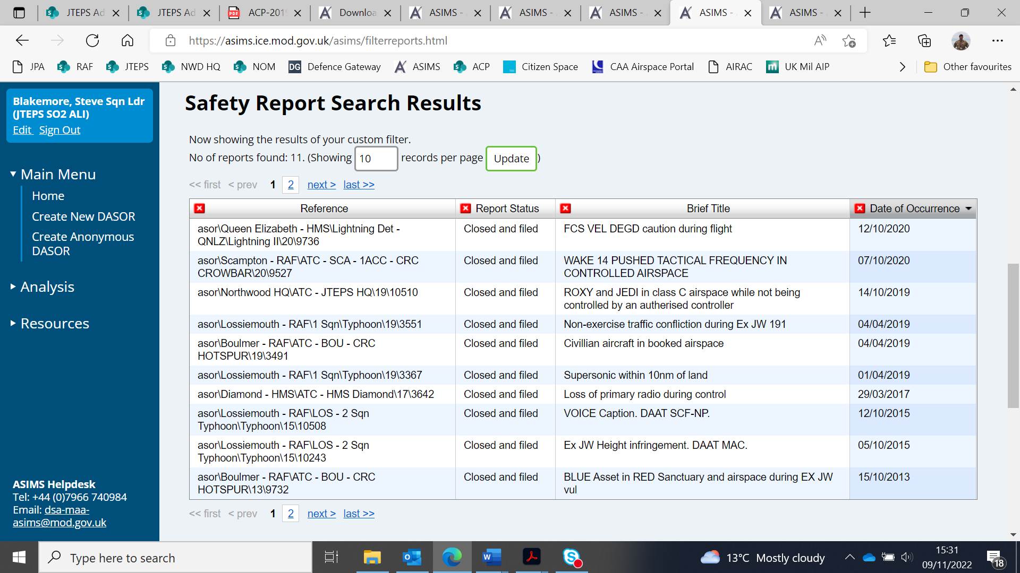

Fig 1 – ASIMS search results.

1.8 High energy manoeuvres would take place during Ex JW, which require segregation from GAT for the protection of both military exercise traffic and civil aviation. In later stages of the design process, the proposal will look to incorporate a flight plan buffer zone (FBZ) to ensure separation in both time and space. The MDA, routings and FBZ should be made known to EUROCONTROL for network visibility reducing the risk of any late notice route changes to aircraft in flight.

1.9 The airspace dimensions in this ACP have been deliberately chosen to remain the same as the FJA previously were during previous Ex JW. This has created a familiarity of the airspace for both the air users, Airspace Battle Managers, Air Traffic Controllers, NATS and the wider airspace community. Because of this familiarity, it will increase pilot capacity using the airspace due to having a greater awareness of the dimensions, reducing their likeliness of accidently leaving the airspace and reducing the chance of MAC. In addition, ATC agencies (78 Sqn and NATS) are familiar with the airspace and its seasonal activation, reducing the chance of human error and decreasing the chance of MAC. The reduction of the chance of MAC aligns to the highest priority Design Principle, ‘The airspace design must be safe, with any hazards identified and risks mitigated such that they are as low as reasonably practicable and tolerable.’

1.10 The FJAs were deliberately constructed to be uncomplex and this proposal has the same attribute. Both airspaces are of a linear shape necessary for efficient air-to-air sorties, with the same planned base height of FL 245. The reduced complexity increases the capacity of the pilots operating in the airspace and the Fighter Controller / ATC providing a service. The uncomplexity reduces the likelihood of both a military aircraft accidently leaving the segregated airspace or of GAT entering the airspace, thereby reducing the chance of MAC.

1.11 Ex JW aims to provide a multi-threat training environment where participants take part in collective training in preparation for deployment as a Combined Joint Task Force. Consequently, aircrew who will be flying in the FJAs are professional aviators, who are Operational Conversion Unit (OCU) qualified and use Ex JW as a workup to real world deployment. A good example of this is from Spring 2021, when after participating on Ex JW 21-1, the UK Carrier Strike Group 21, a British-led naval force (with embarked F-35Bs) deployed on Operation Fortis, a 28-week deployment around the world. Experienced and professional aviators mitigate some of the likeness of an aircraft accidently leaving the FJAs during high energy manoeuvres, further reducing the risk of using this airspace.

**Section 2 – Full Option Appraisal**

2.1 Step 3A requires the Options Appraisal (Phase I) Initial that was carried out in Stage 2 to be developed further by providing quantitative details where required for each shortlisted option, including the ‘do nothing’. The option to have the FJAs included into the UK AIP was assessed against the ‘do nothing’ option based on the SoN:

*In order to meet the complex training objectives of Defence during Ex JWs, a large scale multi-national military exercise, segregated airspace is required that:*

* *Is within reach of Navy Forces, more specifically a Carrier Strike Group (with embarked 5th generation air systems) operating within Deep Water, which through the development of the scenario is likely to span hundreds of miles.*
* *Provides a sufficient mixture of overland and overseas areas which offers exercise planners flexibility to create more complex scenarios across both environments, for necessary littoral operations.*
* *Crucially caters for ranges within the area, which allows for necessary Air Land integration.*
* *Is of large enough size to accommodate representative operational numbers. In order for UK Danger Areas to comply with both the UK’s Airspace Modernisation Strategy and incoming Free Route Airspace (FRA), every danger area requires a “parent” danger area in the UK AIP in order for Flight Buffer Zones to be applied and thus enable FRA. In an increasingly busy UK airspace, segregated airspace of a large enough size and in a suitable location will not exist after FRA is implemented and current solutions are untenable to deliver the required needs of Defence.*

**Design Principles**

2.2 At Stage 1 the Change Sponsor, with feedback from Stakeholders, established a set of Design Principles in which to guide the airspace design options. The design principles agreed at the Stage 1 and 2B Gateway are as follows:

|  |  |
| --- | --- |
| **Priority** | **Design Principles** |
| 1 | DP(a) The airspace design must be safe, with any hazards identified and risks mitigated such that they are as low as reasonably practicable and tolerable. |
| 2 | DP(b) Must be within reach of Navy Forces, more specifically a Carrier Strike Group (with embarked 5th generation air systems) operating within Deep Water, which through the development of the scenario is likely to span hundreds of miles.  DP(c) Provides a sufficient mixture of overland and overseas areas which offers exercise planners flexibility to create more complex scenarios across both environments, for necessary littoral operations.  DP(e) Must be of large enough size to accommodate representative operational numbers.  DP(g) Will be FL 245 and above and suitable dimensions to minimise impact on other airspace users and the network, where possible. |
| 3 | DP(d) Crucially caters for ranges within the area, which allows for necessary Air Land integration.  DP(i) Minimise environmental impacts, where relevant. |
| 4 | DP(f) Safe, efficient and standardised management, notification and activation of airspace, utilising Flexible Use of Airspace (FUA) principles.  DP(h) Minimise noise impacts, where relevant. |
| 5 | DP(k) Protocols for the prioritisation of area activation shall be established to minimise the accumulative overall effect of Defence airspace needs on other airspace users.  DP(j) The design shall provide a Flight Plan Buffer Zone (FBZ) for the purposes of Free Route Operations and flight planning. |

**Option 0 – Do Nothing**

2.3 This option is included for comparison purposes only. The MoD have not conducted an Ex JW without the access to the FJAs since 2021, therefore have had to assume air activity will operate in the current MDA construct as per fig 1 and assess the option against it.

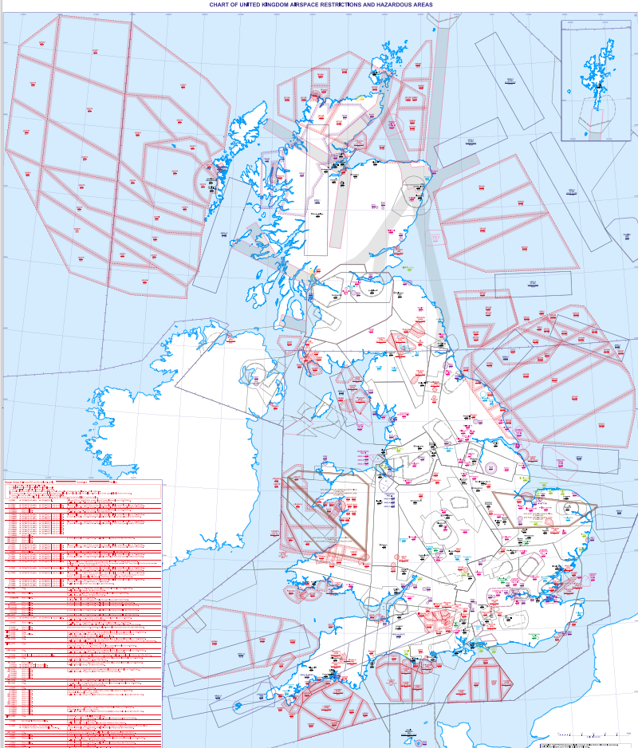

Fig 1 – Current MDA construct.

**Option 0 - Options Appraisal**

|  |  |  |
| --- | --- | --- |
| **Group** | **Impact** | **Level of Analysis** |
| Communities | Noise impact on health and quality of life | Qualitative |
| **Evidence / Analysis** | | |
| The current MDA construct features portions of airspace almost exclusively over sea. MDAs likely to be used in the absence of the FJAs are D701, D712, D323, D613, D513. Overland portions of these are not below FL150 therefore there is no affect to those communities.  Transits to these areas would be from an Aircraft Carrier (predominately Royal Navy QE Class, but also United States Navy and other NATO countries) often situated in the Atlantic and North Sea, using the current Class G and LFA, and would not present any additional traffic. These MDAs are well-established with routes existing to circumnavigate when they are active, with FBZs established around those in FRA. | | |

|  |  |  |
| --- | --- | --- |
| **Group** | **Impact** | **Level of Analysis** |
| Communities | Air quality | Qualitative |
| **Evidence / Analysis** | | |
| The current MDA construct is almost exclusively over the sea at FL150 and above, there is no direct detrimental impact on air quality to communities in the geographical area. Aircraft participating in Large Force Exercises typically operate above FL80, even when the option of going lower is possible, therefore outside the scope of this metric. | | |

|  |  |  |
| --- | --- | --- |
| **Group** | **Impact** | **Level of Analysis** |
| Wider society | Greenhouse gas impact | Quantitative and  monetise |
| **Evidence / Analysis** | | |
| Any activation of an MDA will subsequently mean GAT will be routed around, therefore an increase in greenhouses gasses emitted. This is particularly the case with an activation of any area in EG D701 due to its size and the re-routing of commercial airliners going to and from the West (North American, Europe, etc.), requiring slightly altered journeys. | | |

|  |  |  |
| --- | --- | --- |
| **Group** | **Impact** | **Level of Analysis** |
| Wider society | Capacity / resilience | Qualitative |
| **Evidence / Analysis** | | |
| The current MDA construct is well established with historical data. Effective control measures and managed by the Military Airspace Management Cell (MAMC) are in place in order to minimise disruption. | | |

|  |  |  |
| --- | --- | --- |
| **Group** | **Impact** | **Level of Analysis** |
| General Aviation | Access | Qualitative |
| **Evidence / Analysis** | | |
| The current MDA construct is well established, with effective control measures and managed by the MAMC in order to minimise disruption. Access to the airspace is only denied when active, which, for Ex JW, will solely be during use. | | |

|  |  |  |
| --- | --- | --- |
| **Group** | **Impact** | **Level of Analysis** |
| General Aviation / Commercial Airlines | Economic impact from increased effective capacity | N/A |
| **Evidence / Analysis** | | |
| Outside the scope of this ACP. | | |

|  |  |  |
| --- | --- | --- |
| **Group** | **Impact** | **Level of Analysis** |
| General Aviation / Commercial Airlines | Fuel Burn | Quantitative and monetise |
| **Evidence / Analysis** | | |
| It is likely that fuel burn from commercial airlines will be greater if EG D701s* are activated compared to an activation of FJA(N). Due to the routing of commercial airliners going to and from North America/Europe, a significant amount of those routes go through the areas of D701 complex that don’t go through FJA(N) due to their respective geographic locations. This difference is diminished slightly when FJA(S) is activated compared to FJA(N). Other activation of MDAs (712s, 809s, 613s, 313s) will have negligible difference in fuel burn.  * This is based off a similar size activation of EG D701 as the size of FJA(N), which would often be required due to the representative numbers and tactics used. For example, D701 A,B,C,D,E,G,H,I,Q,R,S,V,W,Y would allow for this. | | |

|  |  |  |
| --- | --- | --- |
| **Group** | **Impact** | **Level of Analysis** |
| Commercial Airlines | Training Costs | N/A |
| **Evidence / Analysis** | | |
| No additional training costs to commercial airlines as a result of using the current MDA structure. | | |

|  |  |  |
| --- | --- | --- |
| **Group** | **Impact** | **Level of Analysis** |
| Commercial Airlines | Other Costs | N/A |
| **Evidence / Analysis** | | |
| No additional costs to commercial airlines as a result of using the current MDA structure. | | |

|  |  |  |
| --- | --- | --- |
| **Group** | **Impact** | **Level of Analysis** |
| Airport / Air Navigation Service Provider | Infrastructure Costs | N/A |
| **Evidence / Analysis** | | |
| No additional infrastructure costs to airports or air navigation service providers as a result of using the current MDA structure. | | |

|  |  |  |
| --- | --- | --- |
| **Group** | **Impact** | **Level of Analysis** |
| Airport / Air Navigation Service Provider | Operational Costs | N/A |
| **Evidence / Analysis** | | |
| No additional operating costs to airports or air navigation service providers as a result of using the current MDA structure. | | |

|  |  |  |
| --- | --- | --- |
| **Group** | **Impact** | **Level of Analysis** |
| Airport / Air Navigation Service Provider | Deployment Costs | N/A |
| **Evidence / Analysis** | | |
| No additional deployment costs to airports or air navigation service providers as a result of using the current MDA structure. | | |

**Summary of Option 0 Full Appraisal**

2.4 Option 0, the do-nothing option, aimed to examine whether alternatives existed which would still facilitate the air elements of Ex JW in accordance with the SoN. There are elements of the current MDAs that do satisfy individual DPs, however there is no specific danger area or combination of danger areas that can be used to facilitate the MoD’s requirements. Lastly, evaluating this option against 11 DPs, it only partially meets 6 and does not meet 1 - (g) There are MDAs which are FL245 and above, however, impact on other airspace users will not be able to be minimised as existing airspace structures will have to be used. This means Ex JW activity would conflict with other military and non-military activity that is occurring in the danger areas, particularly EG D701s with the increase in commercial ventures such as space launches. Showing clearly the current structures are unfit for Ex JW.

**Option 1 – Including FJA(N) and FJA(S) into UK AIP**

2.5 Option 1 is to include of both FJA(N) and FJA(S) into the UK AIP.

2.6 As per figs 2, 3 & 4, the proprosal is for the FJAs to be the same dimensions vertically and laterally as per the Mil AIP ENR.

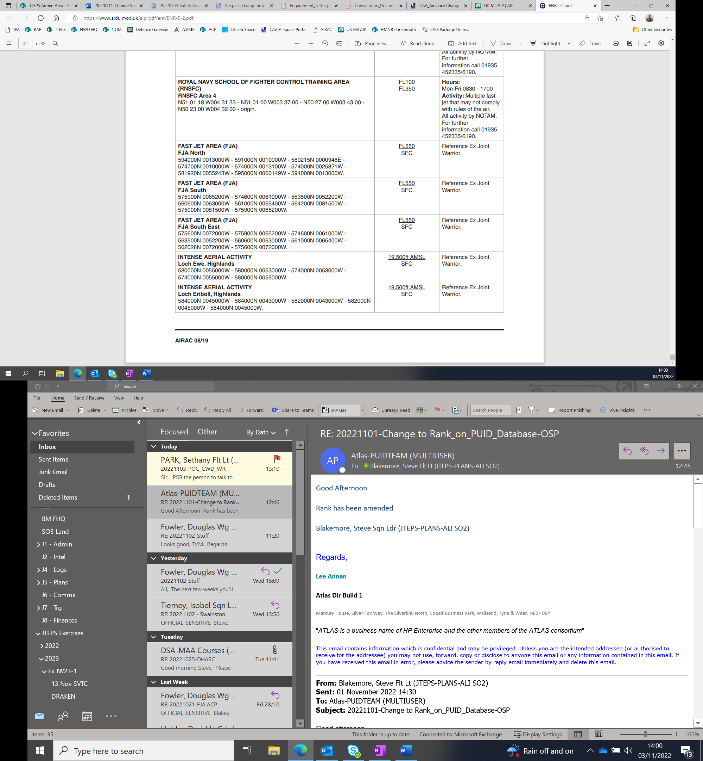

Fig 2 – Mil AIP ENR 5-2 dated 17 Jun 21

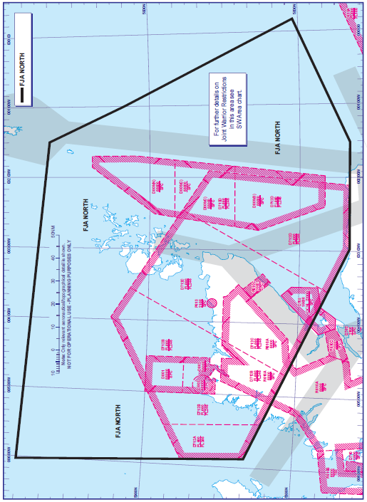

Fig 3 – FJA North, Mil AIP ENR 6-9 dated 28 Mar 19

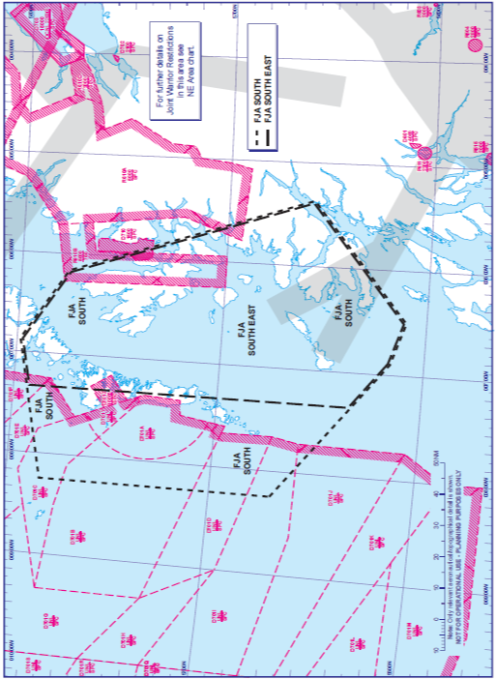

Fig 4 – FJA South, Mil AIP ENR 6-10 dated 28 Mar 19

**Operating Principles**

2.7 **Activation.** The FJAs will be activated via NOTAM when required only during Ex JW (2 weeks in Spring and Autumn) When activated, the FJAs will be afforded the segregated status of Special Use Airspace (SUA) between FL245 and FL550, as defined in CAP 740 Appendix A.

2.8 **Frequency of flights.** It is anticipated that during each of the Ex JW execute phase, there will be approximately 5 activations of the FJAs (total 10 with a 3:2 split of South and North usage[1]).

2.9 **Hours of Operation.** During exercise periods, FJAs will be active for up to 3 hours from mid-morning (c1030 UTC). However, under the EUROCONTROL Flexible Use of Airspace (FUA), the airspace will be managed and handed to Civil use should the FJA not be required (cancellation of aircraft, poor weather, sortie completed early etc.)

2.10 **GAT.** NATS PC will manage the safe and efficient flow of GAT around the FJAs by use of Free Route Airspace (FRA) to facilitate circumnavigation.

2.11 **Operating Authority/OAT.** ASACS units are the Operating Authority for air systems operating within the MDAs/FJA. 78 Sqn is tasked with providing a service to air systems routeing in and out of the MDAs and, in addition, when ASACS is unavailable, for providing a service to air systems operating within them[2].

2.12 Intense aerial activity can be expected with large formations of fast jet attack aircraft (c.40) conducting high energy evasive manoeuvres against opposing air defence aircraft.

2.13 **Letters of Agreement.** The Change Sponsor agrees to create a Letter of Agreement (LoA) in order to deconflict the activation of local airspace and previously agreed protocol:

*C.1.8 In accordance with MoD policy, the MAMC is responsible for ensuring that EG D701E and/or EG D701F activation at or above 29,000ft is not concurrent with EG D712 activation or Military Exercises operating in adjacent Fast Jet Area South (FJAS) or Fast Jet Area North (FJAN). These areas cannot be active at the same time period to allow GAT to transit safely to the east of EG D701E and/or EG D701F.*

This is based on a previous LoA currently within Mil AIP ENR 5-1-7 (fig 5).

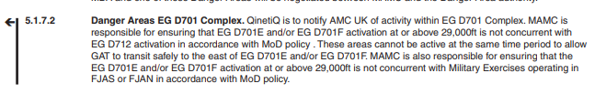

Fig 5 – ENR 5–1–7 dated 12 Aug 21.

**Option 1 - Options Appraisal**

|  |  |  |
| --- | --- | --- |
| **Group** | **Impact** | **Level of Analysis** |
| Communities | Noise impact on health and quality of life | N/A |
| **Evidence / Analysis** | | |
| As a Level M2, CAP1616 states that for aircraft about 7,000 feet, the prioritised environmental impact is CO2 emissions, and an assessment of noise impacts is not normally required. This proposal has the base of the MDA at FL 245, which will significantly reduce/mitigate all noise effects on the ground. Noise impacts were not a concern in any of the stakeholder engagement that was carried out prior to Stage 3A. | | |

|  |  |  |
| --- | --- | --- |
| **Group** | **Impact** | **Level of Analysis** |
| Communities | Air quality | N/A |
| **Evidence / Analysis** | | |
| In accordance with CAP 1616 para B72 this assessment is not required as the proposal will not affect emissions below 1,000 feet. | | |

|  |  |  |
| --- | --- | --- |
| **Group** | **Impact** | **Level of Analysis** |
| Wider society | Greenhouse gas impact | Quantitative and  monetise |
| **Evidence / Analysis** | | |
| Any activation of an MDA will subsequently mean GAT being routed around, therefore potentially more greenhouses gasses emitted. An activation of FJA(S) will likely result in more greenhouse gasses due to its location, disrupting Oceanic traffic, compared to FJA(N). Some impact of the extra greenhouse gases emitted will be balanced by suppression of other MDAs, allowing aircraft more directing routing through them. For detailed quantitative analysis, see annex A. | | |

|  |  |  |
| --- | --- | --- |
| **Group** | **Impact** | **Level of Analysis** |
| Wider society | Capacity / resilience | Qualitative |
| **Evidence / Analysis** | | |
| The FJAs will be managed by the Military Airspace Management Cell to minimise disruption and activation will be via NOTAM. A Letter of Agreement to prevent concurrent activation of MDA airspaces which would affect the network is drafted at para 2.13. Although some routes for commercial flights will be disrupted, other routes will become available as current MDA constructs will not be used. | | |

|  |  |  |
| --- | --- | --- |
| **Group** | **Impact** | **Level of Analysis** |
| General Aviation | Access | Qualitative |
| **Evidence / Analysis** | | |
| The FJAs will be managed by the Military Airspace Management Cell in order to minimise disruption. Access to the airspace is only denied when active, as per the operating principles. Keeping the activations for only when we will be actively using the airspace will mean access impacts are limited, which was a concern raised by the British Gliding Association (BGA).  The base level of the airspace will be FL245 to reduce the impact on lower-level traffic, thus increasing the overall access to airspace, which was a particular issue raised by the British Gliding Association during Stage 1. | | |

|  |  |  |
| --- | --- | --- |
| **Group** | **Impact** | **Level of Analysis** |
| General Aviation / Commercial Airlines | Economic impact from increased effective capacity | N/A |
| **Evidence / Analysis** | | |
| Outside the scope of this ACP | | |

|  |  |  |
| --- | --- | --- |
| **Group** | **Impact** | **Level of Analysis** |
| General Aviation / Commercial Airlines | Fuel Burn | Quantitative and monetise |
| **Evidence / Analysis** | | |
| Projected fuel burn statistics are at annex A. Due to their relative geographic locations, the FJAs will have an inevitable impact on commercial airlines routing to and from Northern America/Europe through the UK FIR.  The Overall Assessment Score 2023-2033, Net Present Value of CO2e equivalent emissions of the proposal is £700,674. The Net Present Value of Traded Sector CO2e equivalent emissions is £6,909. Worktable at annex B.  With the LoA in para 2.17 in use, D701E/F at 29,000ft and above is not active with concurrent operations in FJA(N) or FJA(S) as they would act as a blockage to the NW of the UK FIR. This alone will prevent a large re-routing/disturbance to fuel burn of commercial airlines. | | |

|  |  |  |
| --- | --- | --- |
| **Group** | **Impact** | **Level of Analysis** |
| Commercial Airlines | Training Costs | N/A |
| **Evidence / Analysis** | | |
| No additional training costs to commercial airlines as a result of using this airspace option. | | |

|  |  |  |
| --- | --- | --- |
| **Group** | **Impact** | **Level of Analysis** |
| Commercial Airlines | Other Costs | N/A |
| **Evidence / Analysis** | | |
| No additional costs to commercial airlines as a result of using this airspace option. | | |

|  |  |  |
| --- | --- | --- |
| **Group** | **Impact** | **Level of Analysis** |
| Airport / Air Navigation Service Provider | Infrastructure Costs | N/A |
| **Evidence / Analysis** | | |
| No additional infrastructure costs to airports or air navigation service providers as a result of using this airspace option. | | |

|  |  |  |
| --- | --- | --- |
| **Group** | **Impact** | **Level of Analysis** |
| Airport / Air Navigation Service Provider | Operational Costs | N/A |
| **Evidence / Analysis** | | |
| No additional operational costs to airports or air navigation service providers as a result of using this airspace option. | | |

|  |  |  |
| --- | --- | --- |
| **Group** | **Impact** | **Level of Analysis** |
| Airport / Air Navigation Service Provider | Deployment Costs | Quantitative and monetise |
| **Evidence / Analysis** | | |
| After engaging with NATS, they have estimated ROM costs of £40,000 for NERL En-Route. | | |

**Section 3 – Conclusion**

**Summary**

3.1 The proposed option, ‘Establishing FJA(N) and FJA(S) as per previous dimensions’, option 1, satisfies both the SoN at para 2.1, the Design Principles agreed in Stage 1, and meets 9 out of the 11DPs. It is significantly greater than option 0, do nothing (baseline and comparator), **therefore option 0 is discounted as a design option.** **Option 1 is the only design option that the change sponsor is seeking feedback on**. The DPs that are identified as ‘partial’ will be met with further consultation with stakeholders through the Consultation Feedback Form, available at both annex A and the [Citizen Space Portal](https://consultations.airspacechange.co.uk/mod/inclusion-of-fja-into-uk-aip) when the consultation period begins on Monday 7th December 2022. Continued engagement and consultation will take place with all findings taken into consideration.

3.2 Option 1 meets 9 out of the 11 DPs in para 2.2, with 2 DPs partially met (DP(g) – due to impact on GAT, and (i) – due to the environmental impact on GAT re-routing). With any large force exercise there will always be an impact to other airspace users. Producing a Letter of Agreement to suppress other airspace during FJA activation and having the airspace AMC managed will mitigate this impact. This is largely the same for environmental impacts; where the MoD’s requirement is to operate in large, segregated airspace, GAT will be routed around. The design also satisfies SoN at para 2.1, allowing the MoD to have a geographically relevant segregated airspace in which to exercise modern joint and foreign elements for Ex JW.





3.3 It is assessed that inclusion of the FJAs into UK AIP will have an environmental impact on commercial GAT in a worst-case scenario. This is offset against the MoD’s need to meet the complex training objectives by facilitating joint training in suitable and safe airspace for the largest military exercise in Europe, Ex JW. It is assessed that it will have only a limited impact on a small number of key stakeholders.

3.4 The Change Sponsor proposes that since the impact on other airspace users and the environment is considered to be low, further attempts to provide quantified or monetised analysis would be disproportionate and provide little if any additional clarity for stakeholders.

**ACP Timeline**

3.5 In order to meet the CONSULT Gateway on 25th November 2022, the Change Sponsor will submit all Step 3A documentation to the CAA by Friday 11th November 2022. Any redacted versions will then be uploaded to the Portal.

3.6 Provided a successful pass through the CONSULT Gateway, the Change Sponsor will then commence formal consultation Option 1 from Monday 28th November 2022.

3.7 The following CAP1616 timeline is anticipated:

|  |  |  |
| --- | --- | --- |
| Stage/Step | Description | Gateway Date |
| 3B | CONSULT Gateway | 5th December 2022 |
| 3C | Consultation Launch | 7th December 2022 |
|  | Reminder to Stakeholders | 3rd January 2023 |
|  | Reminder to Stakeholders | 2nd February 2023 |
| 3D | Collate and review responses from consultation. | 24th February 2023 |
| 4A | Update design | 3rd March 2023 |
| 4B | Submit Airspace Proposal to the CAA | 17th March 2023 |
| 5 | DECIDE Gateway | 2nd June 2023 |
| 6 | IMPLEMENT into AIRAC 09/2023 | 9th June 2023 |

3.8 The Change Sponsor will continue the ACP process in accordance with the timeline agreed, submitting all required documentation in Stage 4A and 4B in order to allow the CAA to conduct the DECIDE gateway for 2nd June 2023.

**Annex A – Environmental Impact Assessment**

A.1 NATS Analytics were requested to produce an Environment Impact assessment (A22152) and was based on the following ‘worst case’ assumptions:

* 2x Exercises a year that require the FJAs.
* 5x activations of the FJAs per exercise (10 total).
* FJA(N) and FJA(S) will not be activated at the same time.
* Most common activation is between 1030-1330 UTC.
* Sole activation of FJAs i.e., does not include activation of nearby/overlapping MDAs.

A.2 Simulated baseline air traffic models have been produced using tool NEST (V1.8) and Emissions figures have been produced using BADA 4.2 data. There products have been made available by the European Organisation for the Safety of Air Navigation (EUROCONTROL).

A.3 The traffic sample was taken from the 2205 AIRAC from EUROCONTROL. This AIRAC was chosen to balance the most common activation month (May) with traffic levels returning after the Covid pandemic. A 2022 AIRAC was required to give an up-to-date baseline set of traffic that was not considerably impacted by the Covid-19 pandemic.

A.4 The following 5 days were picked to simulate; 24/05/2022, 30/05/2022, 09/06/2022, 13/06/2022 and 15/06/2022. These 5 days were picked to give a good overall representation of traffic, with the following factors considered; Oceanic Track location (northerly or southerly), Weekday and Traffic count.

A.5 Traffic included must have crossed the Traffic Filter Region (TFR) or the UKFIR (fig 1) during the sample days above. The TFR has been modified to include an area around the Scottish UIR to capture traffic that did not route through the UKFIR on the sample days but would be affected by the changes if the traffic did so. The traffic sample is defined as any flight whose simulated trajectory changed due to the activation of FJA(N) or FJA(S).

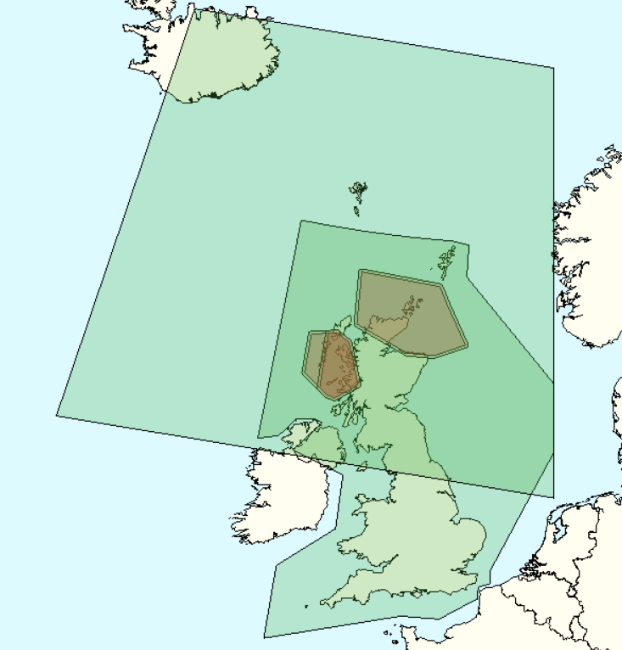

**UK FIR**

**Traffic Filter Region**

**FJA(N)**

**FJA(S)**

Fig 1 – Traffic Filter Region

**Effect on aviation**

A.6 Due to the proximity of the danger areas to the western and northern edges of the UK FIR (London and Scottish UIRs), many flights need to change their UK entry/exit point between the baseline and scenario simulations to produce a valid flight plan. Therefore, the trajectories were simulated within a larger area of airspace called the Simulated Region.

A.7 The Simulated Region is shown at fig 2. It encompasses a section of the oceanic airspace to allow for a degree of change to the Oceanic Entry/Exit point (OEP) to the UK and encompassed a portion of European airspace. This allows transatlantic flights enough area to transverse around the active danger areas while ensuring that the North Atlantic Tracks remained largely unchanged.

A.8 Example trajectories are shown in fig 3. The scenario models show an example of an aircraft trajectory with either FJA activated. The black dots mark the points the aircraft enters and exits the UK FIR.



Fig 2 – Simulated Region

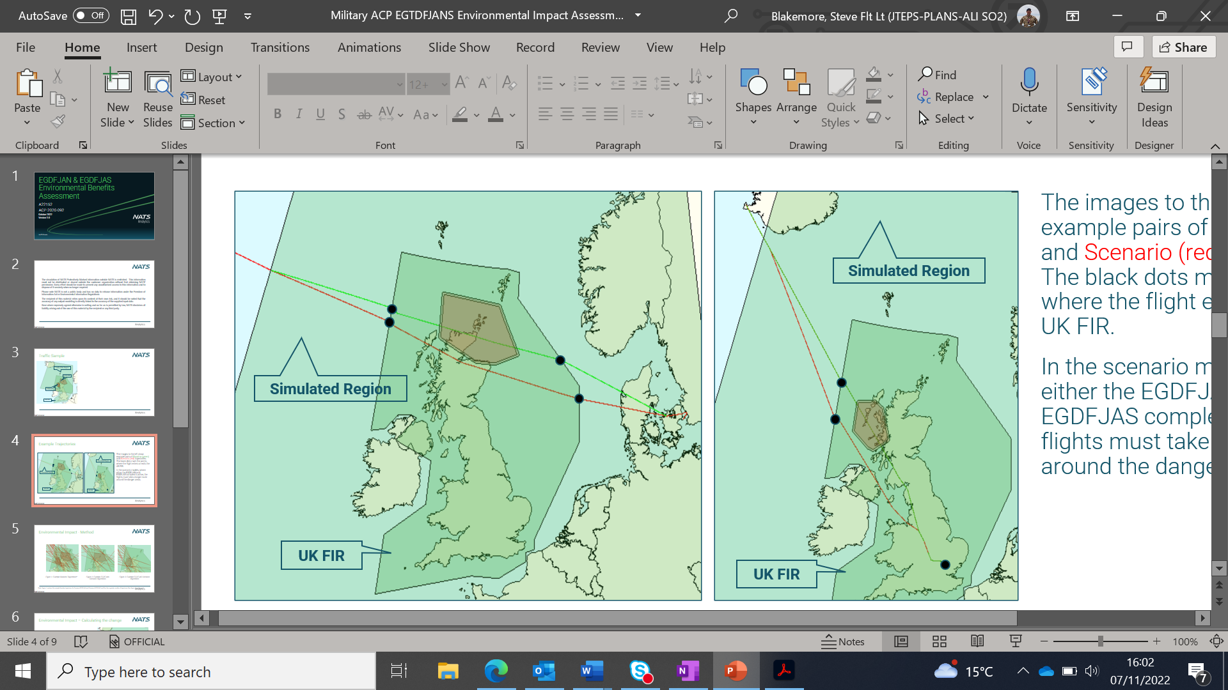

Fig 3 – Example trajectories

**Environmental Impact**

A.9 **Method.** The track distance flown of affected flights was taken from the Baseline and Scenario models and used to calculate the change in distance flown. The fuel burn at cruise by aircraft type was then taken from the BADA 4.2 data tables and used to calculate the fuel burn change based on the change in distance flown.

A.10 The traffic was used to represent an activation of FJA(N) or FJA(S) and the number of activations have been scaled to represent an annual cost (2 exercises (10 total activations) per year assumed based on the historical activation and agreed with the MOD). Fig 4 shows an example of the baseline trajectories vs activation of FJA(N) or FJA(S).

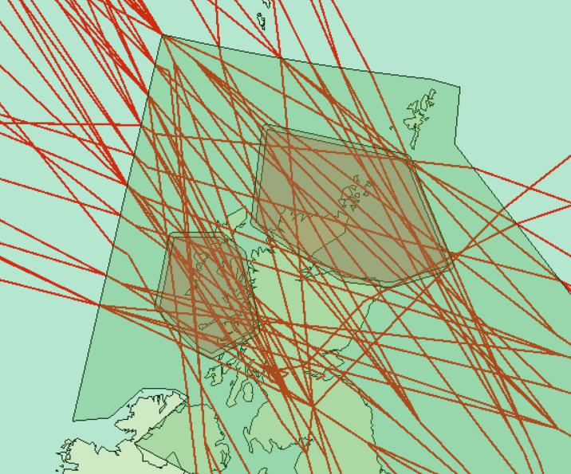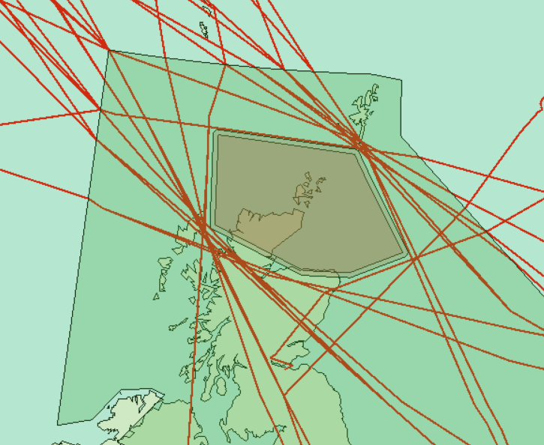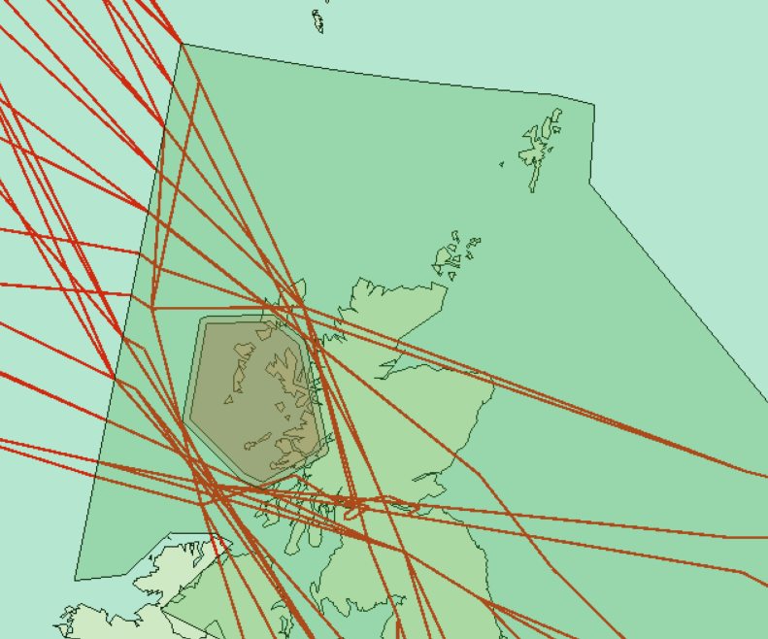

Fig 4 – Example of Baseline trajectories vs EGDFJAN or EGDFJAS activation.

A.11 Traffic was grown using the October 2021 STATFOR forecast and the NATS forecast when STATFOR was not available, to estimate the annual impact to 2033 (10 years post deployment).

A.12 **Calculating the change.** The change in track distance is modelled both as a change in distance within the UKFIR and across the whole trajectory. When viewed as a change only with the UKFIR, the scenarios produced some flights with a reduction in track distance and therefore environmental benefit, example in fig 5. Modelling just for the UKFIR in this example would give a track distance saving of c320NM against an overall trajectory increase of 7NM (scenario – baseline), because of the changes in UK entry and exit fixes. As the implementation of the proposed ACP is to implement areas of airspace that cannot be crossed, it is not sensible for flights to show an improvement in track distance. Therefore, the NATS findings will only report on the ACPs impact to the whole trajectory to be truly representative of the environmental impact.

A.13 **Assumptions.** Along with the assumptions made in para A.1, the modelling took the following into account:

* The fuel impact of this change would manifest as track distance changes while flights are at cruise (the average fuel burn change is calculated from all affected flights across the sample days.)
* Average of 246 flights per activation period.

- Per Activation - 145 flights affected for FJA(N) / 313 flights affected for FJA(S).

- 10:30 to 13:30 UTC is the most common activation time planned in 2023 and is therefore assumed to be the average activation period.

* The fuel burn results have been calculated from the average fuel burn per flight from all flights affected on the samples days, multiplied by the average number of flights during the proposed activation times to give a cost for an average single activation. This value has been multiplied by the estimated number of activations to get the annual values.
* 1% of emissions are traded, 99% are non-traded - For WebTAG submission, the CO2e emissions are reported as traded (flights whose origin and destination are within the EU) or non-traded.

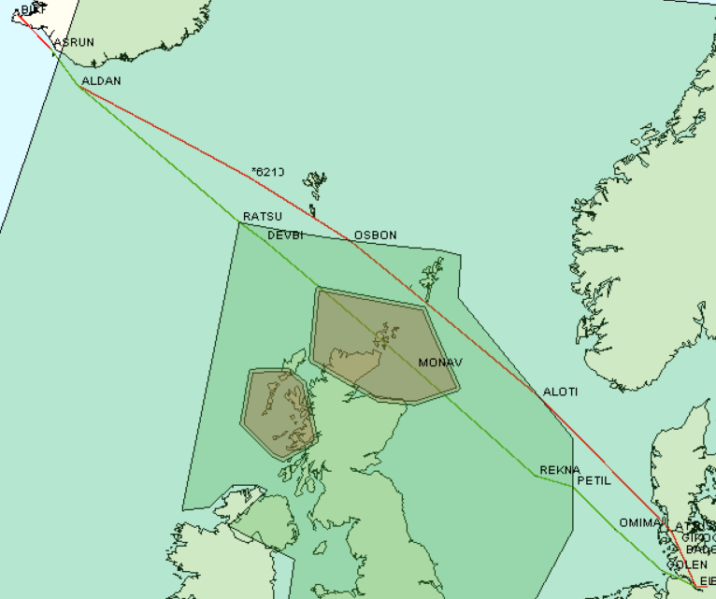

Fig 5 – Example of Environment cost.

A.14 **Results.** The average route length, fuel burn and carbon dioxide equivalent (CO2e) emissions per flight are given in the table below. The average flight has an increased track distance, subsequently increasing the fuel burn and related

emissions.

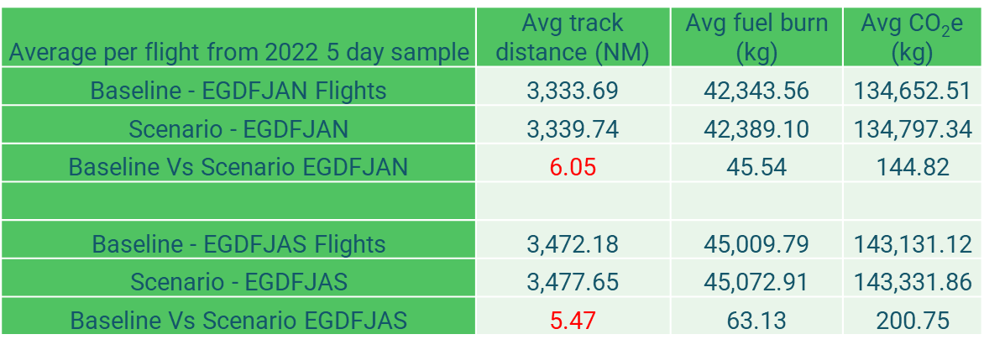

*(Note: CO2e is a standard measurement that considers the impact of all greenhouse gas emissions due to fuel burn as if they were all carbon dioxide. For aviation fuel, the conversion rate is 1kg fuel to 3.18kg of CO2e.)*

A.15 The table below shows the annualised impact of this change in terms of fuel burn and CO2e emissions for years 2023 – 2033.

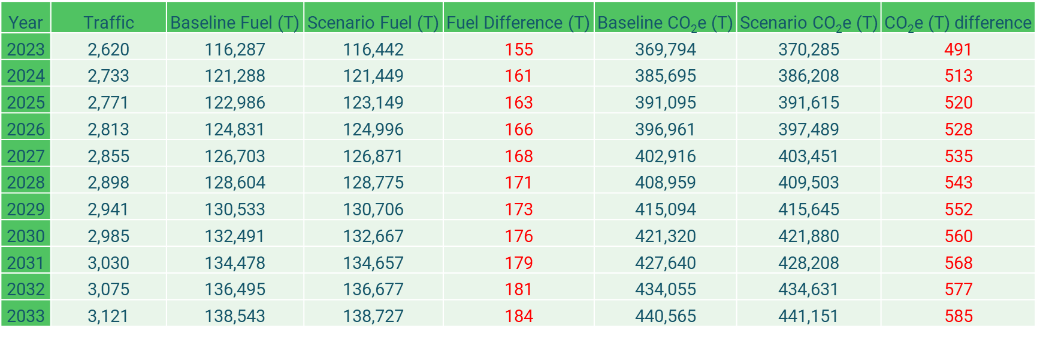

*Note: Positive numbers indicate additional contributions (penalty/cost), negative numbers indicate lower contributions (benefit).* *Calculations are performed on unrounded numbers. Results are displayed to 0 decimal place*

A.16 The table below shows the annualised impact of this change in terms of fuel burn and CO2e emissions for years 2023 –2033 broken down by danger area.

**FJA North**

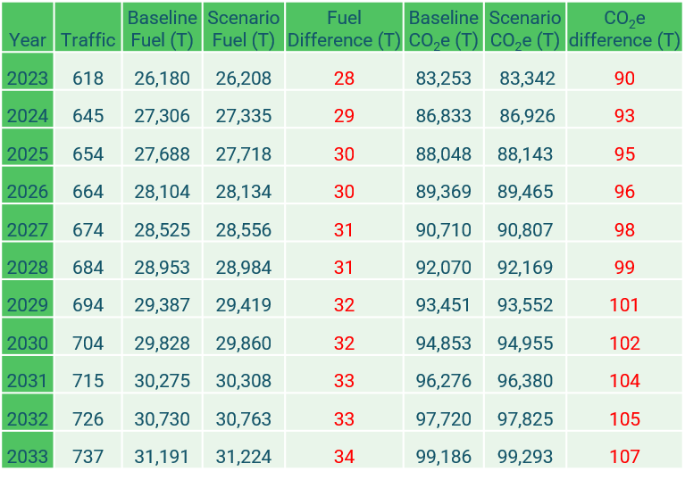

**FJA South**

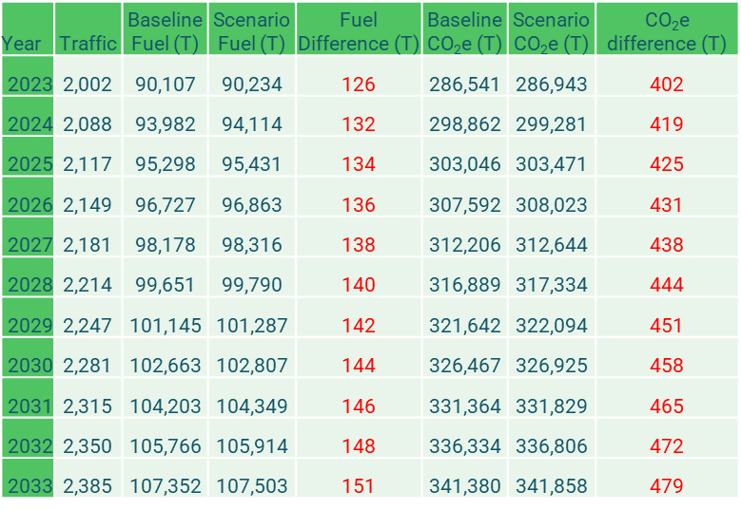

**Annex B – Greenhouse Gasses WebTAG**

B.1 This is the summary page from the Greenhouse Gasses WebTAG workbook at enclosure 1. Negative values are a cost.

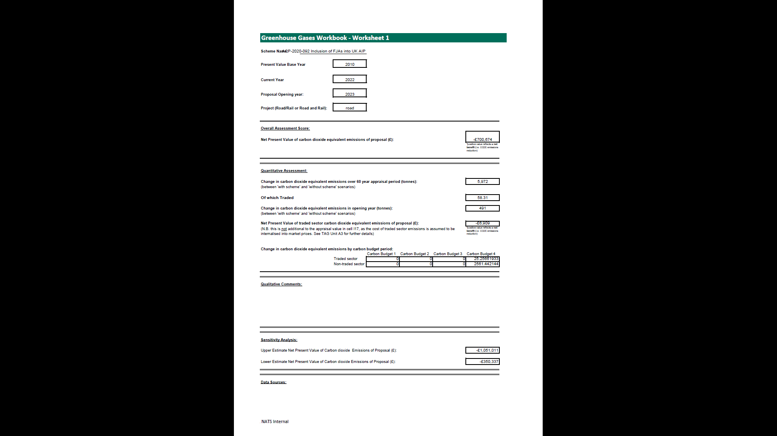

1. Historical activation data 2018-2022, NATS Environmental Impact Assessment A22152.
2. RAF 2 Group HQ Battlespace Management Orders Ed2 V.1.1 Para 128.1, dated 15 September 2022.